Congress:
Lecture 4
_________________ and _________________

“Throw the Bums In”
________________?
I do not tink the word means what you tink that word means.

The Incumbency ________________
Incumbent:
The _______________ officeholder

Advantages:
Staff
____________ (mail)
Publicity
______________
http://www.opensecrets.org/overview/incumbs.php
________________ pays off for incumbents
______________ coverage is higher for incumbents.
Incumbents have greater ____________ recognition due to franking, travel to the district, news coverage.
Members secure policies and programs for voters (_________________) http://www.pryor.senate.gov/public/index.cfm/pressreleases?ID=08a1fa8a-dba6-41ad-af23-af80d0634121

_____________________ is friendly to incumbents.

Disadvantages
We hate the ______________ of incumbency

Congressional Approval Ratings

At the time, December 2010’s 83% disapproval rating was the _______ Gallup has measured in more than 30 years of tracking congressional job performance. Never challenge worse…
Does NOT Compute…
In 2004, 401 of 435 House members ran for re-election. 396 won. (_______%) Of the 26 Senators running, all but _____ won. (96%)
In 2006 Re-election rates were _____… 94.3% in the House, 79% in the Senate
In 2010 - the biggest ________ since 1990, 87% of the House and 84% in the Senate
In 2012, with those incredibly low approval ratings, guess…
_______% in the House and _____% in the Senate! No, I’m not kidding.
Charts from: Center for Responsive Politics

Term Limits
_______ States have passed term limits for their legislative officials; ___ states still have them
Federal Officials remain ____________
Arkansas’s little role in all this:
US TERM LIMITS vs _______________

Some at the Federal level have volunteered to “_________________”
(and usually failed to keep the promise)
Generally, the trend is fading

You Gotta Draw the Line Somewhere…
Reapportionment and Redistricting
I Count!
25 cent word for the day: __________ ________________
Article 1, Section 2 (3) …the actual enumeration…within every subsequent Term of ten years
The census was created to establish the correct number of __________. (Everything else is bonus, or extra-constitutional, take your pick!)

Apportionment
Apportionment - the distribution of voters into districts; the ___________ of _____________ by _______________
Mal-apportionment - large differences in the population of Congressional districts
Reapportionement – the process of redistributing the populations amongst districts
Redistricting – the process of drawing the lines on the maps. Sounds simple, right?

________________ draw Federal House Lines
(Why not ______________?)
Their processes vary dramatically!

Bad Boys, Bad Boys…
_______________ – Governor Eldridge ________ ___________ shaped district
Drawing district lines for ______________ purposes

Packing and Cracking
_________________ – putting _________ of their people in one district
____________ – separating out the opposition so they can’t win

As Little Texas says: God Blessed _________________
It ain’t boring!

A Picture is Worth a Thousand Words
http://nationalatlas.gov/printable/images/preview/congdist/tx32_109.gif
No More Snow for Me!
Changes in Apportionment
Here Come the Judge: _______________________
Apportionment is ________________; they will go “into the thicket”
“I Want to Soak Up the Sun”
Population shifts to the __________ means Yankees are losing seats.
______________ Input: Big Guns, like Former House Majority Whip Tom Delay (Texas R) were purported to be involved in state level issues
Incumbency is ______________

In case you’re interested…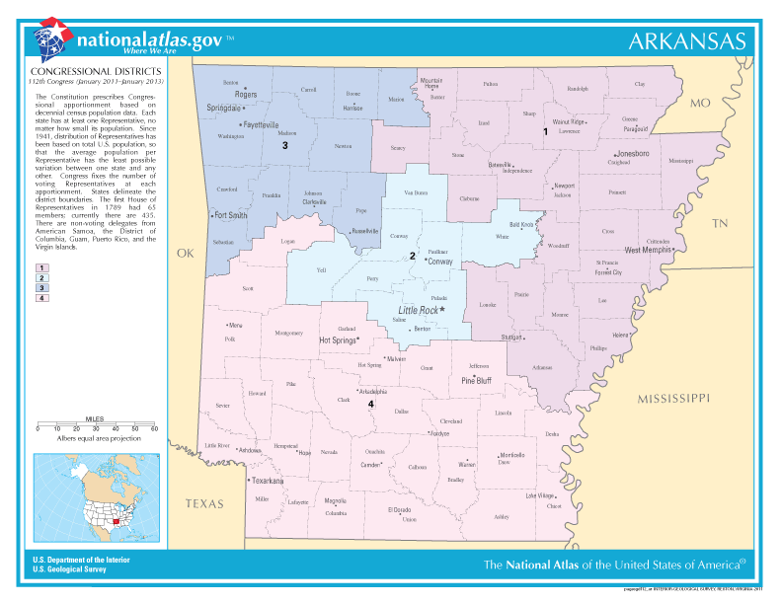

Next: Money and Power:
Appropriations

