Congress:
Lecture 4
Incumbency and Reapportionment

“Throw the Bums In”
Disapproval?
I do not tink the word means what you tink that word means.

The Incumbency Advantage
Incumbent:
The current officeholder

Advantages:
Staff
Franking (mail)
Publicity
Money
http://www.opensecrets.org/overview/incumbs.php
Apathy pays off for incumbents!
Media coverage is higher for incumbents.
Incumbents have greater name recognition due to franking, travel to the district, news coverage.
Members secure policies and programs for voters (Pork) http://www.pryor.senate.gov/public/index.cfm/pressreleases?ID=08a1fa8a-dba6-41ad-af23-af80d0634121

Re-apportionment is friendly to incumbents.

Disadvantages
We hate the IDEA of incumbency

Congressional Approval Ratings

At the time, December 2010’s 83% disapproval rating was the worst Gallup has measured in more than 30 years of tracking congressional job performance. Never challenge worse…
Does NOT Compute…
In 2004, 401 of 435 House members ran for re-election. 396 won. (98.7%) Of the 26 Senators running, all but one won. (96%)
In 2006 Re-election rates were down… 94.3% in the House, 79% in the Senate
In 2010 - the biggest shift since 1990, 87% of the House and 84% in the Senate
In 2012, with those incredibly low approval ratings, guess…
90% in the House and 91% in the Senate! No, I’m not kidding.
Charts from: Center for Responsive Politics
Term Limits
21 States have passed term limits for their legislative officials; 15 states still have them
Federal Officials remain unlimited
Arkansas’s little role in all this:
US TERM LIMITS vs Thornton

Some at the Federal level have volunteered to “self-limit”
(and usually failed to keep the promise)
Generally, the trend is fading

You Gotta Draw the Line Somewhere…
Reapportionment and Redistricting
I Count!
25 cent word for the day: decennial census
Article 1, Section 2 (3) …the actual enumeration…within every subsequent Term of ten years
The census was created to establish the correct number of citizens. (Everything else is bonus, or extra-constitutional, take your pick!)

Apportionment
Apportionment - the distribution of voters into districts; the dividing of representation by population
Mal-apportionment - large differences in the population of Congressional districts
Reapportionment – the process of re-distributing the populations amongst districts
Redistricting – the process of drawing the lines on the maps. Sounds simple, right?

States draw Federal House Lines
(Why not Senate?)
Their processes vary dramatically!

Bad Boys, Bad Boys…
Gerrymander – Governor Eldridge Gerry’s Salamander shaped district
Drawing district lines for partisan purposes

Packing and Cracking
Packing – putting lots of their people in one district
Cracking – separating out the opposition so they can’t win

As Little Texas says: God Blessed Texas
It ain’t boring!

A Picture is Worth a Thousand Words
http://nationalatlas.gov/printable/images/preview/congdist/tx32_109.gif
No More Snow for Me!
Changes in Apportionment
Here Come the Judge: Baker v. Carr
Apportionment is Judiciable; they will go “into the thicket”
“I Want to Soak Up the Sun”
Population shifts to the Sunbelt means Yankees are losing seats.
Federal Input: Big Guns, like Former House Majority Whip Tom Delay (Texas R) were purported to be involved in state level issues
Incumbency is solidifying

In case you’re interested… 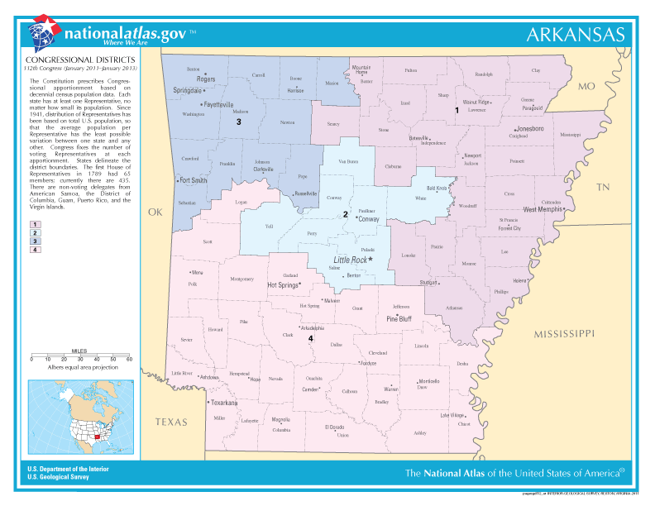

Next: Money and Power:
Appropriations

