The Congress of these United States:
Our Legislative Branch:
Money and
Appropriations

Revenue and Appropriations

Appropriations
Appropriation: the legal _____________________ to expend governmental funds
How we _____________ government

Revenue: ____________________, _______________
Spending: ______________________ Committees

The Big Picture, the whole process: ________________ Committees

To spend money you need:
_________________ (an appropriation)

Funds (___________________)

You must have _______________
A check book with checks but no cash on deposit will get you in trouble
Cash in the bank, but a lost ATM card still means no pizza

You gotta start somewhere…
And for _______________, you start in the ________________ of Representatives

Article I, Section 7 (1) All Bills for raising Revenue shall originate in the House of Representatives; but the Senate may propose or concur with Amendments as on other Bills.

The 1974 Budget Act
An attempt to address the lack of a consistent economic policy
Set up Budget Committees in each house to review President’s Budget in light of all taxing and spending measures
Budget Committees set total __________, ____________ and _____________ levels
Staff for the Budget Committees is the _______________________________
Non-partisan, but not impartial
Legislative/Executive Tension

The Fiscal Calendar
_______________ means having to do with ____________
Federal Fiscal Year: ________________ to September 30
President submits budget in January. Though lately not so much! This year was February 9th.
Budget Committees reviews his plan and sets overall taxing and spending levels in a resolution which must be approved by April 15^{th.}
By mid-June, standing committees have made recommendations to Budget Committee, which draws up a _____________________ bill.
If they can’t come to agreement, things will shut down, unless they pass a Continuing Resolution.
This is their primary job, and they rarely get it done on time! Often they get desperate and pass pork-laden “_______________” bills, or put off the inevitable by funding “______________ Resolutions” (______________). This is no way to run a railroad!

In 2010 they didn’t pass a single budget. NOT ONE. In 2011 we came within hours of a shutdown. For FY 2012, Congress passed consolidated bills Dec 23, 2011. In 2013 we had the Fiscal Cliff and Sequesters. We’ve been limping along on CR’s which expire every few months and in December of 2014 they created…
The (CR)omnibus
An omnibus covering everything but Homeland Security, which got a CR which expired…IN TEN DAYS! Eventually, we resolved it.
In 2015 they passed a CR on December 18th. And John Boehner said goodbye.

My Hero:
http://cooper.house.gov/media-center/press-releases/cooper-introduces-no-budget-no-pay-in-114th-congress
No Woman, No Cry; No Budget, No ____________!

________________ Veto
Declared ________________ in 1998
No line item veto means the President cannot separate out objectionable items from important, helpful items.
Throw out the “baby with the bathwater”

_________________ – a piece of legislation attached as an _______________ to another, possible totally unrelated bill
______________
Oink, oink, oink…
Pork Barrel Spending
Bringing home the bacon

Items of interest to your constituents
(and in a worst case scenario, of service to no one else!)

Trent Lott: There are really three parties: Republicans, Democrats and Appropriats

________________ – Specifying the use of ____________________ funds for a particular purpose in a particular place, meaning __________ district!

Million, Billion Trillion…
"My favorite way to think of it is in terms of seconds," says David Schwartz, a children's book author whose How Much Is a Million? tries to wrap young minds around the concept. "One million seconds comes out to be about 11½ days. A billion seconds is 32 years. And a trillion seconds is 32,000 years. I like to say that I have a pretty good idea what I'll be doing a million seconds from now, no idea what I'll be doing a billion seconds from now, and an excellent idea of what I'll be doing a trillion seconds from now."

Two Key Terms
1) _________________
The Federal Government does not require a balanced budget!
The difference between ______________ (receipts) and __________________ (outlays)
An ________________ measurement of the shortfall
The opposite of surplus
Too much spending, not enough money!
FFY 2007 deficit: $162.8 billion (Down from $337 in ’06!)
FFY 2008 deficit: $459 billion
FFY 2009: $1.42 Trillion! With a T!
FFY 2010: $1.3 Trillion
FFY 2011: $1.3 Trillion
CBO Est. 2012: $1.1Trillion
OMB Est. 2013: $729 Billion
CBO Est. 2014: $485 Billion
CBO Est 2015 $426 Billion
CBO Est 2016: $544 Billion

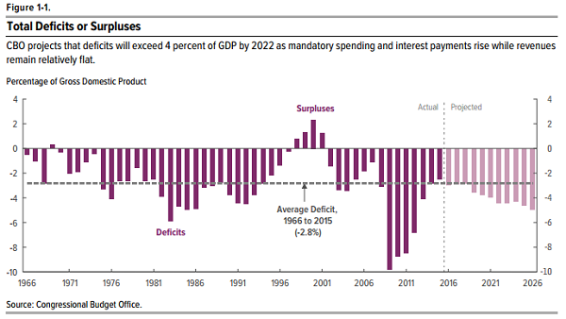

2) Debt
What we _______________ to cover accumulated deficits
The interest will eat you alive!
http://www.treasurydirect.gov/govt/reports/ir/ir_expense.htm
We borrow from ourselves and __________________.

You can have debt without deficits!
We had ____________ budgets (no deficit) in _____________-____________, but we still had debt

Current debt: http://www.brillig.com/debt_clock/

http://www.treasurydirect.gov/NP/BPDLogin?application=np
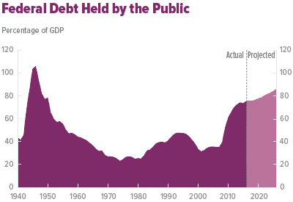

Debt Ceiling:
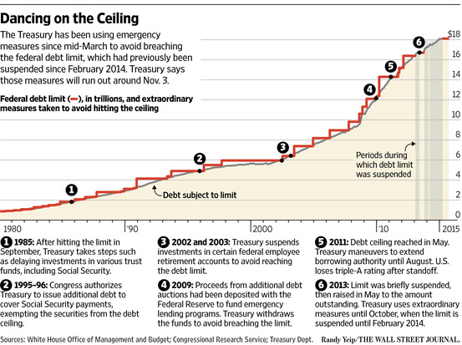

NO way! Government Shutdown? Yes way…
They’ve been happening since the 70’s.
It happened in 1995
Clinton vs. Gingrich.
It lasted 28 days!
This time it went from Oct 1- Oct 17 _______________.
They were trying to avoid the ____________________…
What a mess. And the next month, approval went to _________%

Fiscal Cliff:
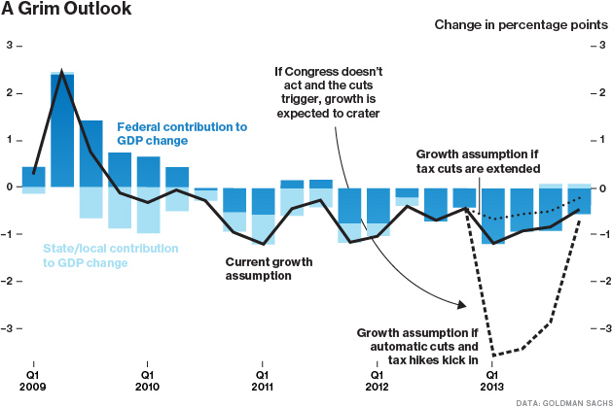

A good place to start:

http://www.concordcoalition.org/
http://federal.budgetchallenge.org/pages/overview

Congress In a Nutshell
A House and a Senate makes a Congress
LOTS of Bills
Few pass
Incumbent rich, Heavy on the Lawyers
LOTS of staff
But less than there once was
At the Moment: Split Party Control
Committees are where the work gets done

They legislate, appropriate, confirm and ratify, oversee and investigate
Inefficient by design
Bicameral, with Checks and Balances
Home of Debaters, Bosses and Managers

Where we all have a voice
Where OUR laws are made

OUR congress: they work for US!

