The Congress of these United States:
Our Legislative Branch:
Money and
Appropriations

Revenue and Appropriations

Appropriations
Appropriation: the legal authorization to expend governmental funds
How we fund government

Revenue: Ways and Means, Finance
Spending: Appropriations Committees

The Big Picture, the whole process: Budget Committees

To spend money you need:
Authorization (an appropriation)

Funds (revenue)

You must have BOTH
A check book with checks but no cash on deposit will get you in trouble
Cash in the bank, but a lost ATM card still means no pizza

You gotta start somewhere…
And for money, you start in the House of Representatives

Article I, Section 7 (1) All Bills for raising Revenue shall originate in the House of Representatives; but the Senate may propose or concur with Amendments as on other Bills.

The 1974 Budget Act
An attempt to address the lack of a consistent economic policy
Set up Budget Committees in each house to review President’s Budget in light of all taxing and spending measures
Budget Committees set total spending, tax and debt levels
Staff for the Budget Committees is the Congressional Budget Office
Non-partisan, but not impartial
Legislative/Executive Tension

The Fiscal Calendar
Fiscal means having to do with money
Federal Fiscal Year: October 1 to September 30
President submits budget in January. Though lately not so much! This year was February 9th.
Budget Committees reviews his plan and sets overall taxing and spending levels in a resolution which must be approved by April 15^{th.}
By mid-June, standing committees have made recommendations to Budget Committee, which draws up a reconciliation bill.
If they can’t come to agreement, things will shut down, unless they pass a Continuing Resolution.
This is their primary job, and they rarely get it done on time! Often they get desperate and pass pork-laden “Omnibus” bills, or put off the inevitable by funding “Continuing Resolutions” (CR’s). This is no way to run a railroad!

In 2010 they didn’t pass a single budget. NOT ONE. In 2011 we came within hours of a shutdown. For FY 2012, Congress passed consolidated bills Dec 23, 2011. IN 2013 we had the Fiscal Cliff and Sequesters. We’ve been limping along on CR’s which expire every few months and in December of 2014 they created…
The (CR)omnibus
AN omnibus covering everything but Homeland Security, which got a CR which expired…IN TEN DAYS! Eventually, we resolved it.
In 2015 they passed a CR on December 18th. And John Boehner said goodbye.

My Hero:
http://cooper.house.gov/media-center/press-releases/cooper-introduces-no-budget-no-pay-in-114th-congress
No Woman, No Cry; No Budget, No Pay!

Line Item Veto
Declared Unconstitutional in 1998
No line item veto means the President cannot separate out objectionable items from important, helpful items.
Throw out the “baby with the bathwater”

Riders – a piece of legislation attached as an amendment to another, possible totally unrelated bill
Pork
Oink, oink, oink…
Pork Barrel Spending
Bringing home the bacon

Items of interest to your constituents
(and in a worst case scenario, of service to no one else!)

Trent Lott: There are really three parties: Republicans, Democrats and Appropriats

Earmarking – Specifying the use of appropriated funds for a particular purpose in a particular place, meaning your district!

Million, Billion Trillion…
"My favorite way to think of it is in terms of seconds," says David Schwartz, a children's book author whose How Much Is a Million? tries to wrap young minds around the concept. "One million seconds comes out to be about 11½ days. A billion seconds is 32 years. And a trillion seconds is 32,000 years. I like to say that I have a pretty good idea what I'll be doing a million seconds from now, no idea what I'll be doing a billion seconds from now, and an excellent idea of what I'll be doing a trillion seconds from now."

Two Key Terms
1) Deficit
The Federal Government does not require a balanced budget!
The difference between revenue (receipts) and expenditures (outlays)
An annual measurement of the shortfall
The opposite of surplus
Too much spending, not enough money!
FFY 2007 deficit: $162.8 billion (Down from $337 in ’06!)
FFY 2008 deficit: $459 billion
FFY 2009: $1.42 Trillion! With a T!
FFY 2010: $1.3 Trillion
FFY 2011: $1.3 Trillion
CBO Est. 2012: $1.1Trillion
OMB Est. 2013: $729 Billion
CBO Est. 2014: $485 Billion
CBO Est 2015 $426 Billion
CBO Est 2016: $544 Billion

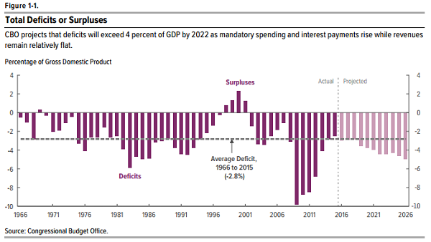

2) Debt
What we borrow to cover accumulated deficits
The interest will eat you alive!
http://www.treasurydirect.gov/govt/reports/ir/ir_expense.htm
We borrow from ourselves and others.

You can have debt without deficits!
We had balanced budgets (no deficit) in 1998-2001, but we still had debt

Current debt: http://www.brillig.com/debt_clock/

http://www.treasurydirect.gov/NP/BPDLogin?application=np
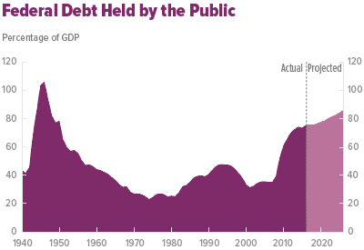

Debt Ceiling:
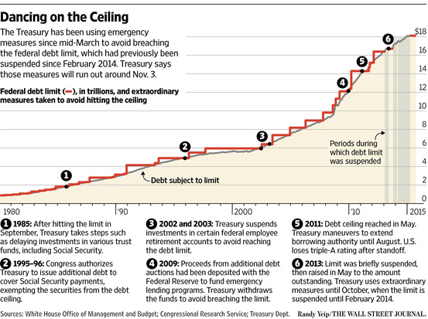

NO way! Government Shutdown? Yes way…
They’ve been happening since the 70’s.
It happened in 1995
Clinton vs. Gingrich.
It lasted 28 days!
This time it went from Oct 1- Oct 17 2013.
They were trying to avoid the Fiscal Cliff…
What a mess. And the next month, approval went to 9%

Fiscal Cliff:
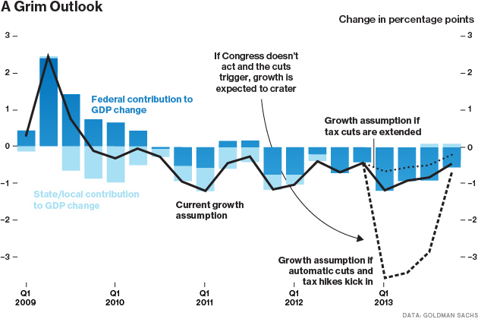

A good place to start:

http://www.concordcoalition.org/
http://federal.budgetchallenge.org/pages/overview

Congress In a Nutshell
A House and a Senate makes a Congress
LOTS of Bills
Few pass
Incumbent rich, Heavy on the Lawyers
LOTS of staff
But less than there once was
At the Moment: Split Party Control
Committees are where the work gets done

They legislate, appropriate, confirm and ratify, oversee and investigate
Inefficient by design
Bicameral, with Checks and Balances
Home of Debaters, Bosses and Managers

Where we all have a voice
Where OUR laws are made

OUR congress: they work for US!

