POLS 205
American National Government
Elections Unit, Lecture 3:
Politics, Polling and Elections

I count!
Politics, Polling and Elections

This totally freaks me out!

Because I’m the mom and I said so, that’s why…
Political Socialization
Why do you vote like you do?
Family
“Hey Dad, what’s happening in the polls?”
Communication
How strongly parents communicate their views
Receptivity
How much children care about what their parents think

Education
The point of public education is to produce educated voters!
A higher level of education means you are more likely to be
Interested
Confident
Active

Religion
Traditional view:
Catholics and Jews are Democrats
Protestants are Republicans
More Accurately:
Degree of Religious Commitment (regular churchgoing)
Conservative, evangelical or fundamentalists
Either of these two factors tend to yield “socially conservative” voters

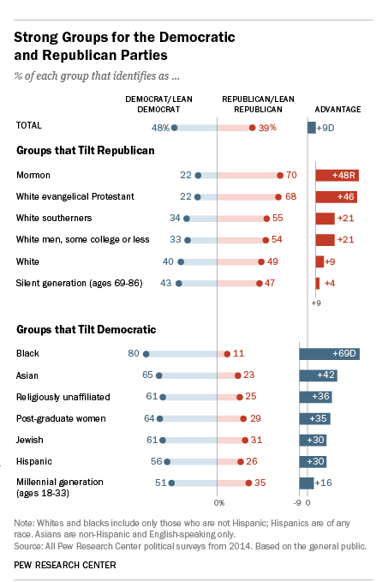General Demographics
Generation (age)
Race
Income
Gender
Soccer Moms, Security Moms, NASCAR Dads, Joe the Plumber, the Walmart Mom, MAGA

Who do & who don’t:
2000 presidential election:105 million people voted!
Unfortunately, that is only 51.2 percent of those who were eligible
Non-presidential years are even worse! 2002 had a 39.3 percent turnout
2004 had an almost 60% turnout! (120 million)
2006 mid-term elections: 136 m. registered; 96 m. voted
2008 Presidential: 132 million, about 62%. Woohoo!
2010 – Mid term – 42%
2012 – Down for a Presidential Year: 57.5%
2014 – 72 year low – 34%
2016 – Was back up! To 59.3%

Why Not?
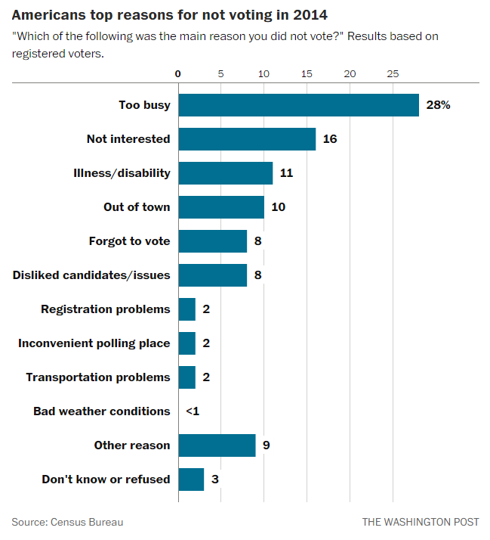
The charts we have been looking at come from polls
Polling houses (PEW, Gallup, Rasmussen, Quinnipiac, Reuters, PPP, etc.) ask a sample (a small group) of people a question, then use that sample to try to predict the same answer for the larger universe.
They don’t ask everyone because it would take forever and be too expensive.
But how they sample, question, and predict makes a world of difference!

I count!
Lies, dang lies, and statistics…

Unfortunately, pollsters and Jon Snow have a lot in common lately.
Or,
How many ways
things can go
wrong in polling:

Sampling Errors: Are you talking to the right people?
Do you just ask anyone about the coming election?
No, wait, they have to be registered voters, right?
DO ALL REGISTERED VOTERS VOTE?
You’re trying to predict the outcome of an election.
DO YOU CARE ABOUT PEOPLE WHO AREN’T GOING TO VOTE?
What would be different if you polled only likely voters?
What Does “Likely Voters” Mean?

Universe of Potential Voters: I’m 18, a citizen, and not a felon
- (VEP – Voting Eligible Population)
Registered Voters
- I’ve bothered to register
Likely Voters
- Yes, I will certainly vote in the next election
- (80% say this…)
Previous Voters
- I’ve voted in the last election
Active Voters
- I always vote

Wishy vs. Washy: Can they give you good answers?
“Undecided”
I Really Don’t Know
Not enough information to decide
Not generally politically engaged
That 20%+ that doesn’t know what they are

“Uncommitted”
I Could Easily Change My Mind
Waiting for the “October Surprise”
Unhappy with the choices
90% will not change

Timeliness and “Social Desirability” in Polling: Will they tell you the truth or what they think you want to hear?
The Swiss Minaret Ban
Sunday's results stood in stark contrast to opinion polls, last taken 10 days ago, that showed 37 percent supporting the proposal. Experts said before the vote that they feared Swiss had pretended during the polling that they opposed the ban because they didn't want to appear intolerant.
The initiative was approved 57.5 to 42.5 percent by some 2.67 million voters.

2014’s Swiss Immigration Vote:
Support for the initiative to “stop mass immigration,” which would impose an upper annual limit on newcomers, has been rising, according to the most recent poll by researcher gfs.bern, published on Jan. 29. While rejection still looks likely, 43 percent of respondents said they’d vote yes, up from 37 percent in a survey published Jan. 10. Fifty percent rejected the proposal, down 6 percentage points from the previous poll. http://www.bloomberg.com/news/2014-02-04/expats-in-crosshairs-as-swiss-vote-on-economy-defining-labor-cap.html
The vote in Switzerland, which is not a member of the European Union but has broad agreements with Brussels, was very close, with the measure favored by just 50.3 percent of those who voted in the referendum. It gives the government three years to come up with legislation imposing immigration quotas and to negotiate with Brussels on how to manage that legislation.
http://www.nytimes.com/2014/02/11/world/europe/swiss-immigration-vote-raises-alarm-across-europe.html

Dearie me, we kind of missed Brexit.

And a rather obvious one from our side of the pond
: 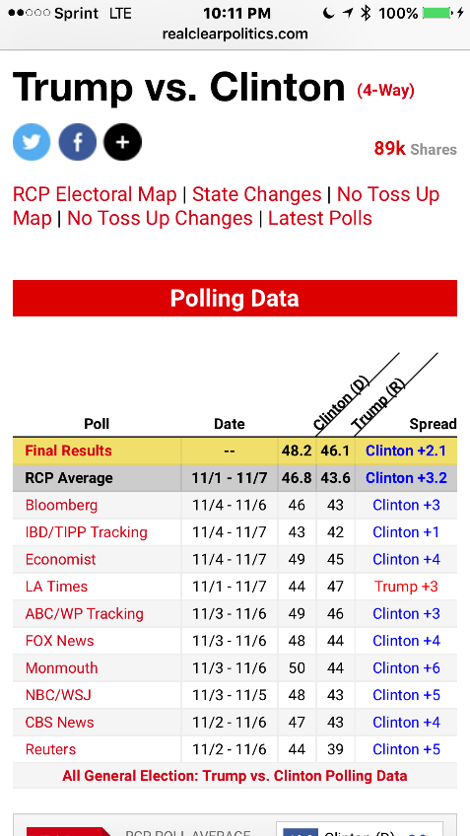
The LA Times: November 9: “All fall, Hillary Clinton has maintained a lead over Donald Trump in a narrow band between 4 and 6 percentage points.”
- The final vote was 46.5% to 48.2%, but 306 to 232 Electoral College
Push Polls, Leading Questions and Half Questions: Are you asking good questions?
Push Polls:
Given the fact that Barack Obama…

Leading questions:
Are you for defending our right to…

Half Questions:
Are you an evangelical?
(Not followed up by how often do you: pray, go to church, evangelize, read your bible…)

Methodology Issues
When, Where and How to ask the questions.
(Phones, internet and exit polls all have their own challenges.)

(And we’re not even going to talk about statistical sampling modifications! Thank Goodness!)

What About Internet Polling?
Remember: Random and Reflective
Unusually motivated participants
Often part of a website with an established position
If so, this is called a self-selecting sample
It can give you a sense of how strongly some people feel about an issue.

But we are getting better at these, (ex: making them more random) while phone polling is getting worse! Internet polls were closer for Brexit!

Exit Polls
Questioning voters as they leave the polling place

Possible problems:
Sampling error
Sample bias
Respondent bias

“Good (ok, at least better) Polls”
Random, Representative Samples = Predictive Answers
Good Polling?
A “Good Poll”:
Random Sample
Representative Sample
Unbiased Questions
Unbiased Methodology
Timely
“Dewey Defeats Truman”: The poll was a week old!
Reagan’s November Surprise: Lots of Un-decideds!
Reflective of Reality
The real test of a poll is how predictive it was. Could you generalize from the poll’s respondents to the actual outcome?

What Makes a Good Sample?
Randomness
Everyone has an equal chance to be selected or represented.

Representativeness
Those selected are a reflective sample of the whole population.

Good Methodology is Still… IFFY!
Margin of Error
The true answer falls within this range based on our poll
Example: A margin of error of plus or minus 4 means that the real answer is within 4 points on either side of our poll’s answer. That’s a total spread of 8 points!
(Standard distribution)

Confidence Level
We are 95% confident that our polled answer is correctly reflecting the overall universe
(1 in 20 times we are wrong!)
Flip a coin

Sample Size
Our sample is big enough to accurately reflect the universe we are trying to predict
N=number of respondents in the sample
A large N = a more reflective sample

Within the Margin of Error?
The final vote was Trump 46.5% to Clinton 48.2%, but 306 to 232 Electoral College

If the final ME was +/- 4, and the aggregated avg. prediction was Clinton 46.8 (50.8/42.8) and Trump 43.6 (47.6/39.6), then IT WAS WITHIN THE MARGIN OF ERROR!
Brexit was pretty close too

How Nerdly Are You?
http://www.realclearpolitics.com/epolls/latest_polls/

If you want to know Presidential Approval Ratings, see how much people hate Congress, or consider the field of Presidential candidates for 2020, REAL CLEAR Politics is a great site.

So, what does all this mean?
The Bones Tell Me Nothing…

The polls ARE important, but be an informed consumer!
They mean something; they just don’t mean everything!

The Poll That Counts The Most
Election Day

Election Reforms
Progressive Reforms:
Direct Primaries - As Opposed To Delegates

Non-partisan Elections –
- 70 % Of Cities Use

At Large Elections
- As Opposed To Wards
- This Has Had Trouble With The Courts Over Race

Direct Democracy:
- Initiative/Referendum/Recall

Secret Ballot
- Bryant/ McKinley Race 1896

National Voter Registration Act of 1993 (The Motor Voter Act)
- Mail in applications
- Governmental agencies serving as registration points
- No removal for simply not voting
- Intent was to expand registration - est. 40 million
- Has yielded an increase in “independent” registration
- California challenged as unfunded mandate, not heard by Supremes

The Most Recent Reform: The Help America Vote Act of 2002
Each state must:
Have a uniform, centralized computerized statewide voter registration database to ensure accurate lists.
Provide provisional ballots to ensure no individual is turned away at the polls.
Provide voters an opportunity to check for and correct ballot errors in a private and independent manner.
Have a voting system that produces a hard copy of ballots for recounts and audits…
Provide at least one voting machine per precinct that is disability accessible.
Have ballots available in multiple languages as required by the Voting Rights Act.
Define what constitutes a legal vote for each type of voting machine used in the state.
Improve ballot access for military and overseas voters.

Other HAVA Provisions
1) Identification Requirements
States must set up new systems to verify voters’ identities:
When registering to vote, individuals must provide a driver’s license number or, if the voter does not have a driver’s license, the last 4 digits of the Social Security number. If an individual does not have either number, he or she will be assigned a unique identifier.
First-time voters who register by mail are required to provide identification when they cast their ballots.

2) States are obligated to maintain clean and accurate voter registration lists.

3) Voters who cast their ballots after the designated poll-closing time as a result of a court order will have their ballots segregated and counted separately.

Voting Troubles
(Packing And Cracking Part 2)
Fraud
Falsified registrations
Lack of a national database
Electronic and mail in registration
Illegally cast ballots
Falsified results
Ballot Box stuffing
New option: electronic devilry
=Bribery, Larceny

Intimidation
Challenged ballots
Provisional ballot
Required by HAVA
Challenged voters
Overly complex systems
Defacto literacy tests
Registration
Voting
Butterfly ballot of 2000 (from a Democratic supervisor)
Vandalism
=Harassment, Thuggery

Election Trends:
Vote by Mail
- Oregon, Washington and Colorado

E-voting
- YIKES!

Automatic registration
- 5 states have adopted automatic registration when you come into contact with the government, unless you opt out.

Early/Absentee Voting without excuse
- 35 states
- Estimated 40% voted early in 2012 and 2016
- (15% in 2000, 33% in 2008)
- Florida is estimated to be 80%!!!

Increased participation?
- We’ll see…

It really DOES matter…
…Every voter, as surely as your chief magistrate, under the same high sanction, though in a different sphere, exercises a public trust.
Grover Cleveland, Inaugural Address

Pray like Solomon, ‘cause you are in charge!
Mrs. K

