Strange Math – Expanding on the Bill of Rights

Incorporation and Privacy

The Fifth Amendment

**No person shall be held to answer for a capital, or otherwise infamous crime, unless on a presentment or indictment of a Grand Jury, except in cases arising in the land or naval forces, or in the Militia, when in actual service in time of War or public danger; nor shall any person be subject for the same offence to be twice put in jeopardy of life or limb, nor shall be compelled in any criminal case to be a witness against himself, nor be deprived of life, liberty, or property, without due process of law; nor shall private property be taken for public use without just compensation.**

Due Process: An established course for judicial proceedings or other governmental activities designed to safeguard the legal rights of the individual.

Procedural Due Process:

HOW - Procedures

Before you can be relieved of “life, liberty or property” there has to be a fair trial, and you have to have the chance to affect the outcome.

Substantive Due Process:

WHY - Substance

The Government cannot pass law that would unfairly or inappropriately deny any enumerated or implied liberties or rights.

Dred Scott (1856), Lochner v. New York (1905)

**The Doctrine of Incorporation**

Expanding on the Bill Of Rights:

The Civil War Amendments: 13,14 and 15 (1865, 1868 ,1870)

Amendment 13 - Slavery Abolished

Amendment 14 - Citizenship Rights, Due Process, Equal Protection

Amendment 15 - Race no bar to vote

The Real Key is Section 1 of Amendment 14 –

1. All persons born or naturalized in the United States, and subject to the jurisdiction thereof, are citizens of the United States and of the State wherein they reside. No State shall make or enforce any law which shall abridge the privileges or immunities of citizens of the United States; nor shall any State deprive any person of life, liberty, or property, without due process of law; nor deny to any person within its jurisdiction the equal protection of the laws.

***States* shall provide due process and guarantee equal protection under the laws**

Strange Math, Part One:

14 X 2 + 57 years + 5 = 10 (or more!)

The Doctrine of Incorporation

**The guarantee of due process in the 5th and 14th amendments, and of equal protection in the 14th amendment, allows the Supreme Court to incorporate other constitutional rights when limiting state governments in their actions against citizens**

Or in plain English: Does the Bill of Rights apply to the states? Yes, yes it does. Well, mostly… (Partial Incorporation)

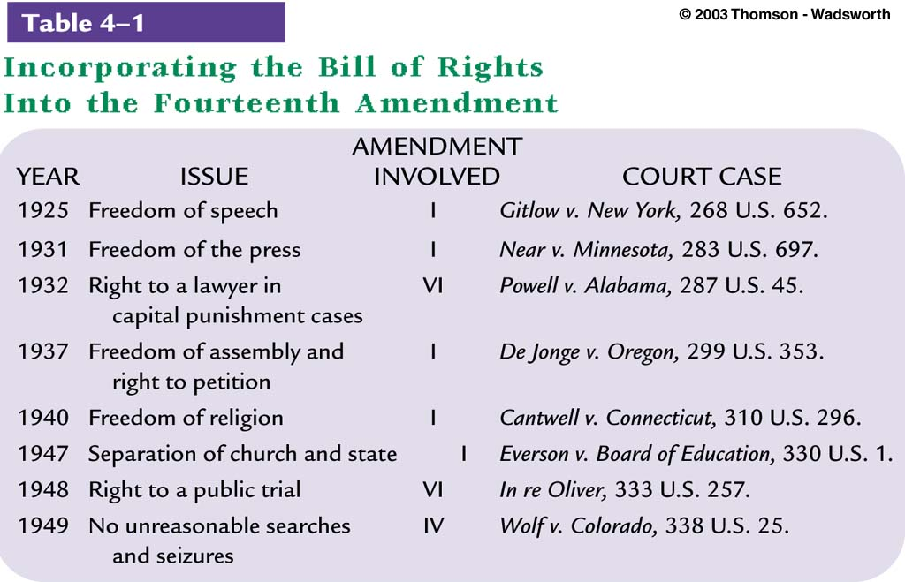

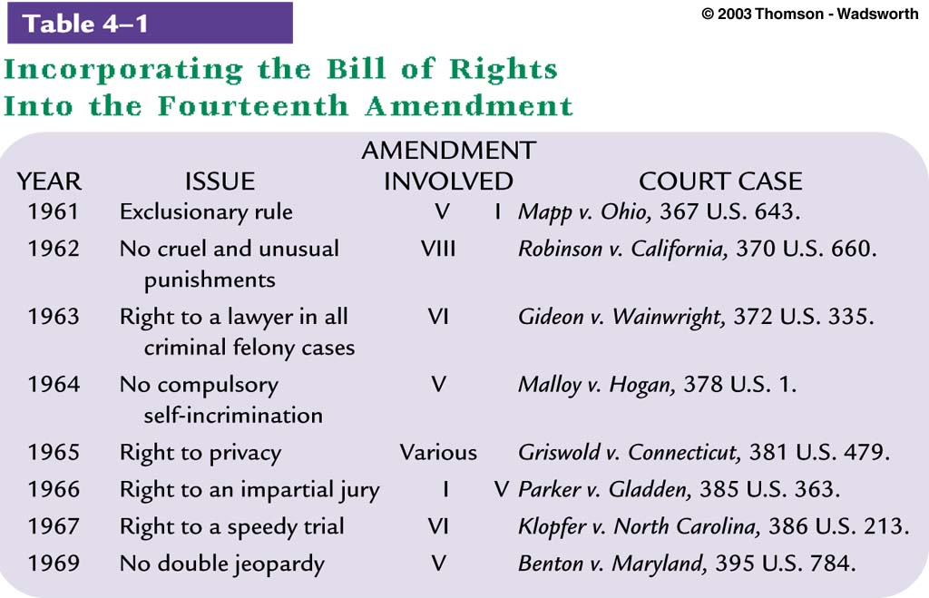



**Right to Privacy**

Strange Math, Part Two:

“Right to Privacy”

Not an explicit constitutional term; it is “inferred”

Griswold v. Connecticut (1965)

Justice Douglas: 1st, 3rd, 4th, 5th, and 9th Amendments create penumbras, formed by emanations from those guarantees that give them life and substance.”

Why Civil Liberties Are Like My Waistline:

They are ever expanding!

Free Speech: Now includes “symbolic speech”

Due Process: First expanded to include state court systems, now includes the bureaucratic process (administrative hearings), and other individual rights through the Doctrine of Incorporation

Privacy: Created from Amendments 1,3,4,5,and 9. Now includes “consenting adult activity”.