- Executive Branch and Cabinets

Local Observations
City Hall –
2nd Tuesday of the month
Call ahead to be sure.
Seriously – you don’t want to meet the Searcy PD…

Why do they do that 2nd Tuesday thing?
Because the Thursday before every meeting there is a “Pre-Council”
Can we go to that one?
You betcha!

Two Hints for Test Three
Do Your Readings!
Know Your People!

Let’s Talk About Governors
Who Are They? What Do They Do?
Gubernatorial Demographics
Political Career Paths

Roles of Governors (NOT Powers)
Chief of State
Commander in Chief
Chief Administrator (CEO)
History
General trend of increasing power, increasing centralization
Began as a VERY weak office
Jacksonian populism began growth in power

Results: Consolidation of agencies, extended terms, veto power

Rosenthal’s Informal Powers:
Initiation
Publicity
Power of Party/ Party Leadership

Let’s Talk About Governors: Strong vs Weak
Table 6.1, pp. 208-209:
Institutional Powers
(Schlesinger/Beyle)
Seperately Elected Officials,
Tenure Potential,
Appointment Powers,
Budget Power,
Veto Power,
Party Control
(Six scores averaged)

Table 6.2, pp. 215-216:
Personal Powers
(Thad Beyle)
Electoral Mandate,
Ambition Ladder,
Personal Future’
General Performance,
GPP: Governor’s Personal Power Index
(Four scores averaged)

“It Varies From State to State”
Lieutenant Governor
Runs on a separate ticket in 18 states
Serves as President of the Senate in 20 states
Seven states make do without! (New Jersey finally got one in 2010!)
Variance in power is HUGE! (Texas vs. Florida)

Constitutional Officers
Attorney General: All 50 states; elected in 43 states
Secretary of State: In 47 states; elected in 36 states
Treasurer of State: In 48 states; elected in 36 states
Auditor of State (or Comptroller): In 25 states

Partisan…
http://ballotpedia.org/Gubernatorial_and_legislative_party_control_of_state_government

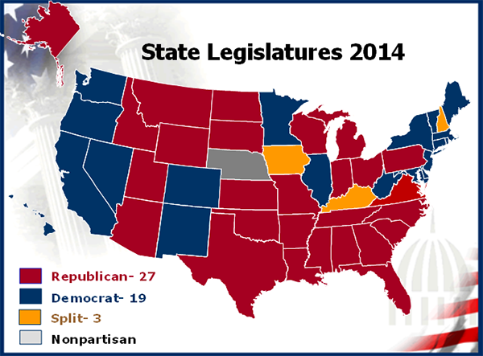
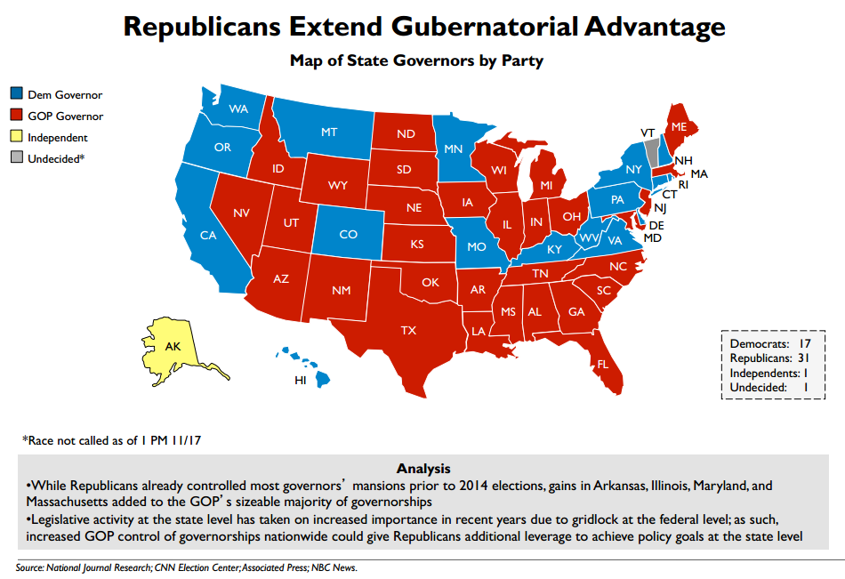

Arkansas’ Executive Branch
Governor’s Powers:
Separately elected officials
- Lt Gov, Sec of State, Treasurer, Auditor, Atty General
Tenure potential
- Two 4 year terms
Appointment power
- 3000 board appointments; all vacancies but US House, Assembly or Lt Gov
Budget power
- Recommends budget to Assembly
Veto power
- 5 days to sign or veto; has line item veto; only takes 50%+1 to override
- No pocket veto
Party control (not an enumerated power)
- De facto party leader

Other Powers or Roles:
Legislative
- Calls special sessions and dictates an agenda that must be completed first
- Proposes “Governor’s Package” and “Governor’s Program” (p35 GIA)
Judicial
- Reprieves
- Commutations (Rockefeller the first)
- Pardons
- Also, extradition and fills judicial vacancies
Commander in Chief
- Head of Arkansas National Guard (until activated or “called up”) (Faubus)
Reorganizes Gov’t
- Last major reorg was 1971 under Bumpers (60 down to 13)
- 2003 Huckabee tried for 50 down to 10

NOT A GOOD YEAR FOR CABINET OFFICERS….
Lieutenant Governor of Arkansas
- The State’s VP
- Runs on separate ticket (as in 18 other states)
- Serves as President of the Senate
- Assumes Duties and Powers of the Governor (and now “office”) if the Governor is unavailable.
- Former LT Gov Mark Darr (R) resigned effective Feb 1, 2014 after the Ethics Commission sanctioned him regarding campaign finance rules.

- Other Constitutional Officers
- Attorney General
- Secretary of State
- Treasurer of State
- Auditor of State
- Special Statutory Officer
Commissioner of State Lands
- Attorney General
The State’s Lawyer
Leslie Rutledge (R)
(Former AG Dustin McDaniel (D) didn’t run for Governor after all, what with his affair with the “craziest lawyer in all of Hot Springs” going public…)

- Secretary of State
The State’s Race Car driver…
Mark Martin (R)
The State’s Record Keeper
(Was the state’s fiddle player: Charlie Daniels(D))

- Treasurer of State
The State’s Bank (and Investment Banker)
Dennis Milligan (R)

(Former Treasurer Martha Shoffner (D) resigned due to a bakery/bribery scandal. Seriously. You can’t make that up.)

- Auditor of State
The State’s Accountant
Andrea Lea (R)

(Also was once Charlie Daniels – He was especially good at musical chairs!)

- Commissioner of State Lands
The State’s Repo Man
Returns defaulted land back to tax paying status
Special Statutory Officer
John Thurston (R)

(This was the race with Elvis D. Presley as a write-in candidate. Imposter. Everyone knows Elvis’ middle initial was A!)

Boards and Commissions
- Semi-independent, appointed authorities who control among other things:
- Land use
- Professional licensure and practice
- Education
- Expenditure of state funds
- Biggest: State Highway Commission, State Economic Development Board

- http://arkansasedc.com/
- http://www.arkansashighways.com/commission.aspx
- http://www.aroptometry.org/

- Let’s talk about footnotes
- Kate Turabian – a paper writer’s BFF, which is a little creepy, since she’s been dead since 1987.

- Your research project requires Turabian style footnotes. If you haven’t already got a copy, get one!

