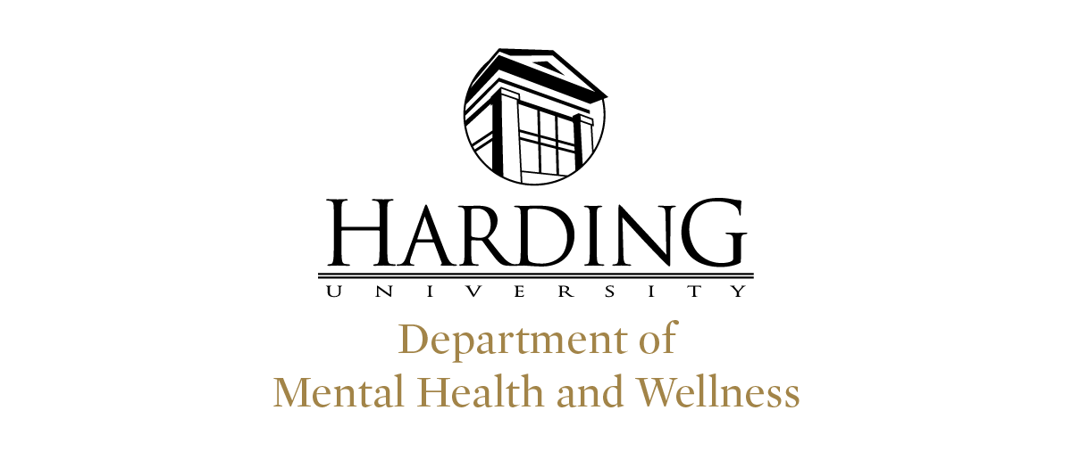

Summary of Program
The Professional Counseling Program’s personnel at the end of academic year 2021- 2022 totaled seven core faculty and one Program Coordinator. Our adjunct faculty includes two CACREP trained counselor educators, and a doctor of pharmacy. The program accepted 60 students from an applicant pool of 63, and 53 of those began the program. We had 99 students in seats this year. Our student body is currently 66% female and 34% male, 87% white, with African American, Asian, Hispanic, American Indian, Foreign National, and other making up the remaining 13%.

Faculty Achievements
Faculty in the program made 65 presentations, attended 6 professional meetings, served on 10 University committees, and served on 6 state committees.
Faculty Committees & Leadership Positions:
- Past President of Arkansas Association for Counselor Education and Supervision
- President Elect of Arkansas Counseling Association
- Annual Fall Conference Chair of Arkansas Counseling Association
- Co-coordinated Annual Midwinter ArACES conference (virtual) and coordinated CACREP Self-Study for Reaccreditation
- Academic Leaders committee
- Faculty Advisor for the Chi Sigma Iota Chapter of CSI.
- Arkansas Board of examiners in counseling member
- Faculty Evaluation Committee
- Community Committee for Lament
- Interprofessional Experiential member
- Mental Health and Wellness Leadership committee
- DESE - School Counseling licensure review
- Board Member of the Botham Jean Foundation, Inc
- Harding University's Global Outreach Mission Trip to St. Lucia
- Supervision Training Department Committee
- Internship Review Department Committee
Faculty Awards
- Rosenthal Award for Outstanding Service to the Counseling Profession in Arkansas
Faculty Presentations Included:
- “Self-Care”
- “Panel Discussion”
- “Catastrophic News Delivered Compassionately”
- “Comfort Zones for Provider Growth and Patient Care”
- “Support for New Professional School Counselors”
- “University Panel”
- “Mental Health Challenges in Schools”
- “Stress Pathways: Anxiety or Resilience”
- “Understanding self through MBTI”
- “Multicultural Supervision”
- “Understanding Reactions to Childhood Trauma”
- “Disciples Forgive; Understanding How Forgiveness Heals”
- “Restoring A Sense of Calm, Both In and Out of the Classroom”
- “Mind Your Gaps; Mental Health Panel”
- "Technology in the Age of COVID-19”
- “Supervision: An Overview”
- “Counselor Self Care”
- “Mental Health and Ministry”
- “Synchronous Supervision: Making the Most of Video Conferencing Experience”
- “Created for Connection”
- “Suicide Prevention”
- “Intimacy: A Model for Change”
- “How to Leave a Dysfunctional Family”
- “New Dating Rules”
- “Lessons We Can Learn from Dogs”
- “Career Lessons From 007”
- “How SCARY is TOO SCARY for Kids?”
- “Handling a Tough Move”
- “How to be an Advocate”
- “Women of STEM"
- “Bigger isn't Always Better”
- "Health Benefits of Giving Thanks"
- “How to See Another Person's Perspective”
- “The Current Need to Give Blood”
- “How to Have Happier Holidays”
- "Dealing with Mistakes from the Past"
- “National Introvert Week”
- “Blue Monday: Overcoming the Blues"
- “S.A.D. Seasonal Affective Disorder”
- "When a Vacation Goes Wrong"
- "Helping Kids Deal with Disappointment"
- “Introverts and Extroverts”
- “Can a Tough Past Make You Stronger”
- “Severe Grief”
- "The Powerful of Meaningful Goals"
- "Optimism"
- “Learning from the Deaf Community"
- “DID: Dissociative Identity Disorder”
- “How Scary is TOO Scary?”
- “Family History: Genograms”
- "Avoiding the Peter Principle"
- “Military Appreciation”
- "Top Costumes: Why to Costume (or not)"
- “The Power of Gratitude”
- “Joining God in His Mission: Reach out to Hurting People”
- “Spiritual Upgrades”
- “Father's Day: 4 Gifts Every Child Deserves”
- “Mother's Day: How God is Like A MOM”
- “Dealing with the Unexpected”
- “The Good Samaritan: Racial Advocacy”
- “Counseling Ethics Made Easy: It's Not Rocket Science: but... it can either get you to the moon, or blow up in your face :)”
- “Strategies to Address Adolescent Cutting and Self-Harm”
- “Multicultural and Diversity Aspects of Supervision”
- “Responses to ADHD Profiles in High School and College”
Workshops, Professional Meetings, and CEs attended Included:
- ArCA State Conference
- ArACES State Conference
- ACA Conference
- Arkansas Counseling Association Leadership Development Conference
- Arkansas ASPA Conference
- Mental Health & Wellness Dept--Generational Differences

Program Achievements
The program was once more involved with community events, recognitions, and trainings. The program continued to see growth in the 2021-2022 school year. The counseling
program’s Advisory Committee, which is comprised of representatives from CASA, Prime Care, Cabot and Searcy schools, Arisa Health, Child Safety Center, Families, Inc. and several private practice therapists met in October and were given an update on all that had been accomplished across the year. Discussion included topics such as addressing the mental health needs across the state, educating school-based services due to the high need. Teaching about the collaboration and relationship between therapists and school faculty., providing self-care workshops and support groups, working to bring diversity to the program/areas of counseling, helping student learn how to interview for jobs, and addressing gaps in understanding of child welfare and hotline information and the specifics of that, especially focused on AR
We had several physical events and presentations sponsored by our Chi Sigma Iota chapter for the 2021-2022 school year. We had an in-person induction ceremony, mental health screenings, several mental health panels, and a presentation on “Pornography Addiction and Prevention.”

The Rogers site of the Professional Counseling program offered or sponsored several trainings for the community in conjunction with community agencies including “Suicide Assessment with Adolescents”, “Just Ethics”, and “Core Skills Ethics.”

The Memphis site of the Professional Counseling program continued offering monthly CE meetings are held for counseling professionals on that site as a part of collaborative work and outreach in the Memphis community. Some of these training were entitled “Preventing Burn-out”, “Helping Clients with Sleep”, “Pharmacologic Treatment of Mental Health Conditions in Adolescents”, and “Self-Care.”
Inter-professional experiences were provided. Students and faculty participated in an ongoing inter-professional experiential (IPE) collaboration with the Health Sciences programs on campus for collaborative case studies. The Professional Counseling program was active in leadership in both fall and spring IPE activities with faculty acting as emcees and discussion leaders and multiple students serving as round table facilitators.

The Professional Counseling program teamed with the Health Sciences, Public Safety, local law enforcement, paramedics, and the hospital in April for the annual Disaster Drill on campus. This year’s simulation focused on tornado drill.

Academically, the program has continued to prepare for reaccreditation and preparation for adherence to the new 2016 standards. The marriage and family therapy program has begun to be integrated with the clinical mental health and school counseling entry level
specialty areas as it prepares for initial accreditation. The self-study was completed and submitted in November 2021!

It is important to note that the COVID 19 pandemic still created some challenges for the program and its students during the 2021-2022 year.

Counseling program/student outcomes
In 2021-2022 academic year, 100% of Professional School Counseling candidates from the Professional Counseling program who took the Praxis II School Counseling Exam 0421 (which measures knowledge and skills and is required for licensing in School Counseling) made a passing score. In the 2021-2022 academic year, 100% of Clinical Mental Health Counseling candidates from the Professional Counseling program who took the National Counselor Exam (NCE) or comprehensive exam assessing knowledge, skills, and abilities made a passing score (which is determined using the Angoff formula) on first attempt.

The program had 10 students graduate in December 2021, 15 students graduate in May 2022, and 18 students graduated in July 2022. Completion rates are currently at 88% for clinical mental health students and 82% for school counseling students.
Fall 2021- 10 grads
  - Seacy (CMHC: 7, MFC: 1, SC: 0)
  - Rogers (CMHC: 0, MFC: 0, SC: 1)
  - Memphis (CMHC: 1, MFC: 0, SC: 0)
Spring 2022- 15 grads
  - Seacy (CMHC: 10, MFC: 0, SC: 0)
  - Rogers (CMHC: 1, MFC: 0, SC: 1)
  - Memphis (CMHC: 3, MFC: 0, SC: 0)
Summer 2022- 18 grads
  - Seacy (CMHC: 8, MFC: 7, SC: 0)
  - Rogers (CMHC: 1, MFC: 0, SC: 0)
  - Memphis (CMHC: 2, MFC: 0, SC: 0)
Current program job placement rate for the last year, defined as the number of students who, within six months of receiving their degree have obtained employment in the field they were trained or a related field, is 86% for clinical mental health and 80% for school counseling, and 55% for marriage family counseling (*note mfc students are not yet three months out from graduation yet).

