PRELIMINARY DESIGN REPORT TO THE NASA 2011 UNIVERSITY STUDENT LAUNCH INITIATIVE

A Study of Solar Irradiance as a Function of Altitude

By
HARDING FLYING BISON
2011 USLI ROCKET TEAM

November 19, 2010

Matthew Irvine, Team Leader Edmond Wilson, Ph.D., Team Official

Table of Contents

- Summary of PDR Report
  - Team Summary
  - Launch Vehicle Summary
  - Payload Summary
- Changes made since proposal
- Vehicle Criteria
  - Selection, Design, and Verification of Launch Vehicle
  - Recovery Subsystem
  - Mission Performance Predictions
  - Payload Integration
  - Launch Operation Procedures
  - Safety and Environment (Vehicle)
- Payload Criteria
  - Selection, Design, and Verification of Payload Experiment
  - Payload Concept Features and Definition
  - Science Value
  - Safety and Environment (Payload)
- Activity Plan
- Conclusion

1. Summary
1.1 Team summary
We are the Harding University Flying Bison Rocket team. The University is located at 915 East Market Street, Searcy, Arkansas. Our mentor and team official is Dr. Edmond Wilson.

1.2 Launch Vehicle Summary
1.2.1 Vehicle size

This year we will be flying a rocket with a diameter of six inches. The rocket will be 121 inches in length, and 620 ounces. We chose to increase the size of our rocket to be able to incorporate our payload which is significantly larger than last year. We will use a pre-glassed phenolic airframe. The added strength will mean extra weight, but this will be offset by a more powerful motor. We will use an aft section that is 42 inches in length, a drogue section that is 16 inches in length, and a main section that is 36 inches in length.

1.2.2 Motor selection

We have selected to use the L-1222 hybrid motor from Contrail Rocket. We chose to fly a hybrid partly because the University is responsible for research on the composition of hybrid motor emissions using spectroscopy. There are also safety benefits. Storing hybrid motors has minimal risk because the solid grain must have an oxidizer to burn. The L-1222 has a length of 52.75 inches and a weight of 175.982 ounces. It burns for 3.1 seconds with a total impulse of 3693.88 Newton-seconds. The maximum thrust is 2689 Newtons.

1.2.3 Recovery system

We will deploy a drogue parachute at apogee. We will be using the 44” SkyAngle for our drogue parachute. We will deploy the main chute at 800 feet. We will use the 120” conical parachute from Public Missile as our main parachute. The rocket will descend around 65 ft/s and 20 ft/s under drogue and main respectively. We will use two PerfectFlight mini Altimeters to deploy the main and drogue parachutes. After the rocket has landed, we will use the Walston retrieval system to track its position.
1.3 Payload Summary
We are integrating the payload suggested by the Science Mission Directorate. We will take data for the temperature, humidity, pressure, solar irradiance, and ultraviolet radiation during descent and after landing. We will also take three pictures during descent and three pictures after the payload has landed. We intend to separate the payload from the airframe at 2,500 feet.

2. Changes Made Since Proposal

2.1 Changes to the vehicle

We have made significant changes to the vehicle design since the proposal. Our original diameter of 6 inches remains the same, but we have increase the airframe length from 9.3 feet to 10.1 feet. We have decided on dimensions for each section on the airframe. The L369 motor did not provide an adequate thrust, so we have switched our motor selection to an L-1222. This greatly increases our thrust to weight ratio. Due to an incomplete mass analysis, our RockSim results from the proposal have been deemed incorrect and have been since corrected for the detailed corrected masses.

2.2 Changes made to the payload

Our payload was not very well defined during the proposal stage, but we were able to produce a detailed design of our payload for the SMD. Since this payload addendum, we have not made many changes to the payload. We decided to remove the moveable parachute rods due to worries that the static rods would have negative effects on the efficiency of the parachute. We have however introduced a single fixed rod to the center of the top plate of the payload. This is intended to hold the payload secure within the airframe and take the shock of the separation charge for the payload. It is also intended to catch the parachute so that it will not fall onto the payload and block sensors.

2.3 Changes made to other areas

We have set dates for outreach with the local Cub Scouts and have made more contacts for outreach opportunities since the proposal was completed. Our business division has also secured funding from the Arkansas Space Grant Consortium. We continue to look into funding opportunities from the private sector.

3. Vehicle Criteria
3.1 Selection, design, and verification of launch vehicle

    - Mission statement, requirements, and mission success criteria
Mission Statement:
Our mission is to design, build, test, and fly a high powered hybrid rocket that will reach an altitude of exactly 1.00 mile and carry a deployable science payload that will take data for studying the atmosphere during descent and after landing. The measurements will include temperature, pressure, relative humidity, solar irradiance and ultraviolet radiation. Another part of our mission is to capture images during descent and after landing. This mission will be done safely with no injuries, no damage to property, and the entire rocket vehicle will be recovered without receiving any damage that would prevent it from further use.
Requirements:
In order to meet these mission goals, the following systems and plans must be procured or produced:
- Hybrid rocket motor using nitrous oxide oxidizer and hydroxyterminated polybutadiene with a 3694 Newton-second total impulse
- Nitrous oxide oxidizer supply tank that can deliver 10 liters of liquid nitrous with pressure regulator, fill and dump valves, temperature control to keep pressure between 600 and 900 psi
- Remote battery operated ignition system with 500 feet of cable that can control the fill and dump lines of the nitrous oxidizer supply and set off the electric matches which ignite Pyrodex pellets initiating the hybrid rocket flight
- On-board flight computer with backup computer capable of monitoring and recording apogee altitude and having pre-programmed capability to set of ejection charges to deploy a drogue parachute at apogee and a main parachute at 800 feet. Computers should have separate power supplies and manual switches to turn them on just before flight.
- Drogue and Main parachutes: drogue to deploy at apogee with main to deploy at 800 ft. Parachutes attached to airframe securely with ample shock cord to prevent breaking of shock cord and minimizing collision and entanglement of separated airframe parts
- Airframe that can withstand flight stresses and landing damage and carry the science payload, motor, recovery parachutes, flight recorder safely through the planned trajectory
- Fins that help maintain smooth and stable flight pattern with minimum turbulence
- Science payload with separate power supply to record temperature, pressure, relative humidity, solar irradiance, ultraviolet radiation, and capture images. An embedded controller will be required to activate the sensors, record and store their signals and provide interface to retrieve data at the end of the flight
- Portable Launch Stand for holding, aiming and releasing rocket for flight
- Scale drawings of all components, systems and subsystems to be assembled into the final competition rocket including launch stand and fixtures used to construct sub-assemblies
- Inventory Manual of all items needed for successful and safe flight of competition rocket at USLI launch site
- Procedures Manual for preparation of the rocket for flight
- Safety Manual for safety procedures, safety information and best safe practices to be followed including MSDS sheets of all chemicals used
Mission Success Criteria:
The mission will be a success if the following objectives are met:
Pre-Launch
- Complete assembly
- Electronics activated and responsive
- Full battery Charge
- Establish RF connection
- Proper Motor preparation
Launch
- Motor Ignition
- Rocket successfully leaves launch pad
- Correct thrust to weight ratio
- Stable flight by guidance rail
- Stabilization by fins
- Maintains integrity despite (LAUNCH) forces
- Motor burns completely
Flight
- Barometric system locked
- Thrust launches rocket to 5280 feet altitude
- Apogee reached
- Gauged by accelerometers/barometer
- Drogue parachute launched
- Rocket successfully separate
- Drogue Parachute Successfully deploy
- Rocket begins descent
- Barometer detects altitude of 800 feet
- Main parachute deploys
- Rocket successfully separates again
- Main parachute successfully deploys
- Rocket decelerates to 17 feet per second
- Rocket Lands
Recovery
- Power maintained throughout flight
- GPS sends coordinates
- Rocket recovered
- Data retrieved within 30 minute window
- Integrity
- Airframe integrity maintained
- Electronics functionality maintained
- Rocket remains in reusable condition
Major Reports
- Proposal submitted on time
- Web Site Active
- PDR submitted on time
- CDR submitted on time
- FRR submitted on time
- Final Report submitted on time
Safety and Environment
- No injuries to life forms
- Environment not affected

    - Major milestone schedule

Task | Oct | Nov | Dec | Jan | Feb | Mar | Apr
Preliminary Design Report Due 19 Nov 2010 | -------------- | --------⌂
Preliminary Design Review, PDR 6 Dec 2010 | -------------- | -------------- | --⌂
Critical Design Report Due 24 Jan 2011 | -------------- | -------------- | -------------- | -----------⌂
Critical Design Review, CDR 2 Feb 2011 | -------------- | -------------- | -------------- | -------------- | --⌂
Flight Readiness Report Due 21 Mar 2011 | -------------- | -------------- | -------------- | -------------- | -------------- | ---------⌂
Flight Readiness Review, FRR 28 Mar 2011 | -------------- | -------------- | -------------- | -------------- | -------------- | -------------⌂
USLI Launch Competition, 13-16 Apr 2011 | -------------- | -------------- | -------------- | -------------- | -------------- | -------------- | -----⌂
Post Launch Assessment Review, PLAR, 9 May 2011 | -------------- | -------------- | -------------- | -------------- | -------------- | -------------- | -----------
Test Launch of Scale Model with Science Payload Prototype | -------------- | ----------⌂
Airframe Division
Final Design of Airframe | -------------- | -------------- | ------⌂
Order Materials for Airframe | -------------- | -------------- | --------⌂
Conduct Testing of Airframe and Airframe Components | -------------- | ----------⌂
Build and Paint Airframe | -------------- | -------------- | -------------- | -------------- | -------⌂
Motor Division
Order Motor and Ignition Hardware and materials | -------------- | -------------- | ---------⌂
Prepare Detailed Procedure for Motor Preparation and Flight | -------------- | -------------- | -------------- | -------------- | ----------⌂
Prepare Safety Document for Motor, fuel and oxidizer transportation, flight preparation, ignition, flight, maintenance, stowage | -------------- | -------------- | -------------- | ---------⌂
Static Testing of Rocket Motors | -------------- | -------------- | -------------- | -----------⌂
Science Payload Division
Design and Build Payload | -------------- | -------------- | -------⌂
Choose and Purchase Embedded Controller | -------------- | -------------- | -------⌂
Integrate payload and Controller into Airframe | -------------- | -------------- | -------------- | -------------- | -------⌂
Laboratory Test Payload | -------------- | -------------- | -------------- | -------------- | -------⌂
Prepare Operations Guide for Payload | -------------- | -------------- | -------------- | ---------⌂
Avionics Division
Laboratory Test of Avionics Computers | -------------- | -------------- | -------------- | -------------- | -------⌂
Install Flight Computers into Airframe | -------------- | -------------- | -------------- | -------------- | ---⌂
Launch Operations Division
Prepare Inventory of Materials, Equipment, Supplies | -------------- | -------------- | -------------- | -------------- | ---⌂
Order Needed Materials and Supplies | -------------- | -------------- | --------⌂
Test Launch Rocket in Memphis | -------------- | -------------- | -------------- | -------------- | ------------⌂
Prep and Launch Rocket at USLI Competition | -------------- | -------------- | -------------- | -------------- | -------------- | -------------- | -----------
Outreach Division
Design and Implement Harding Flying Bison USLI Website | -----------⌂
Outreach Project at area schools | -------------- | -------------- | -------------- | -------------- | -------------- | -------------- | ⌂
Outreach Project with Girls Scouts and Boy Scouts | -------------- | -------------- | -------⌂
Carry Out and Record Publicity Projects | -------------- | -------------- | -------------- | -------------- | -------------- | -------------- | ⌂
Seek External Funding | -------------- | -------------- | -------------- | ⌂
Recruit New Team Members | -------------- | -------------- | -------------- | -------------- | -------------- | -------------- | -----------

    - Functional system requirements

A 6.00 inch diameter airframe appears to be the only option for the payload that we have selected. We were able to find a motor that gave us the needed power to reach our goal. We currently have an over stable rocket, but we continue to look at solutions to this problem. We will most likely choose different fins then the ones currently selected. This will help to give us a better stability and allow for a heavier rocket.
The motor we chose is a Contrail Rockets Certified L-1222 Hybrid Motor with a Total Impulse of 3694 N∙s and Burn Time of 3.1 s. The 3.00 in diameter motor is composed of two chambers: a 3200 cc nitrous oxide chamber, bolted to a 12 inch solid fuel grain combustion chamber. This configuration comes with a “medium speed” nozzle. The Coaxial Vent Assembly allows for the vent to be routed through the combustion chamber. This eliminates the need for a top vent on motors, a distinct advantage over previous designs. These Contrail 75mm Motors fit Standard Aero Pac Motor Retainers another advantage when constructing the rocket. The rocket motor is 52.75 in long and 2.95 in. in diameter. It has four – 3/16 in injectors plus a 1/8” vent.
The parachutes will be deployed using black powder separation charges. We chose this method because it has proved very reliable over time and in our testing. We have previously tested the strength of our shock cords and shown their factor of safety is suitable for our application. We have also tested the strength of our coupler sections to show that they can handle the forces from the separation process.

    - Subsystems

Subsystems are:
· Aft airframe consisting of
· -Motor retention system: We are using a motor retainer that screws on to the end of the motor mount tube
· -Motor mounting tube: We are using tubing of 36” to mount the motor
· -Aft fins: We have selected to use the Public Missile Bulldog fins but this selection is currently under review
· -Motor: The motor will be a Contrail Hybrid L-1222
· Forward airframe consisting of
· -Flight computer number 1: PerfectFlight
· -Flight computer number 2: PerfectFlight
· -Battery power supply
-Drogue Parachute: SkyAngle 44” Classic
-Main Parachute: Public Missile 120” conical
· Nose cone
-Payload: See section four for details

    - Performance characteristics, evaluation and verification metrics, and verification plan

We have not determined the performance characteristics of our system as of yet. We will be conducting laboratory and field testing on our system later in the year, at which time we will have a better idea of how our system performs.

We plan to test our launch vehicle for strength. We expect all of our tests to be successful and show that our material choices have been sufficient. We plan to set our evaluation to simulate the forces of different landing conditions. We will also test all payload operations in the laboratory to ensure that they work properly. We continue to test all of our altimeters before each flight to ensure proper operation. We also test the separation charges to ensure that they have enough impulse to separate the airframe. We have begun testing on our ignition system. We have discovered problems that are currently being diagnosed and solved.

3.1.6 Risk analysis

Risks | Repercussions | Mitigation
Lab Equipment Tools | Improper use can result in severe bodily harm | Users will familiarize themselves with the proper safety protocols with each tool in the laboratory. All safety equipment and apparel will be utilized and used when laboratory equipment is in use.
Lab Materials that will be used | Direct contact can cause skin and/or eye irritation. | Users will familiarize themselves with the proper safety protocols with each material used during this project. All safety equipment and apparel will be utilized and used when hazardous materials are being used. When materials are not being used they will be stored and sealed from accidental exposure.
ICB handling and electrical package usage. | Improper assembling of the electrical equipment can damage components and cause burns by shorting equipment. | All equipment will be set up according to their specifications. Users will wear an electrostatic bracelet when handling equipment to prevent any static buildup during use. Users will insure that when assembling electrical equipment that no power source is attached and will only attach the power source in a testing/live use of equipment.
Solid Rocket Engine Propellant | Direct contact can cause skin and throat irritation. Accidental ignition could cause severe burns/bodily harm. | Proper safety apparel will be used when handling solid rocket engine propellant such as latex gloves. Propellant will be securely stored until needed. Solid rocket engine propellant near an open flame or heat source will never be handled. Members statically discharge themselves before handling the propellant to prevent accidental static discharge when handling propellant.
Black Powder blasting caps to deploy the recovery | Direct exposure to skin can cause mild irritation. Accidental ignition could cause burns/bodily harm. | Proper safety apparel, such as latex gloves, will be used when handling black powder caps. The caps will be securely stored until needed. The caps are never to be handled near an open heat source. Members will statically discharge themselves before handling the caps to prevent accidental static discharge when handling propellant.
On-site ground testing dangers | Risk of bodily harm, damaging or losing rocket, electronic payload/sensors. | Extensive analysis of simulated flight data to ensure proper flight conditions are met before ground test occurs. Testing electronic equipment in laboratory conditions first to ensure they are functioning properly. When handling the solid rocket propellant all apparel and precautions will be abided by. A complete checklist will be made and analyzed to ensure a safe and successful test. All preflight checklists will be checked and will not proceed until all are met.
Extra Vehicular Electronics Sensory Package Testing | Risk of injury. Risk of damaging sensors, electronics, or the vehicle itself. | Extensive analysis of simulated flight data to ensure proper flight conditions are met before ground test occurs. Testing electronic equipment in laboratory conditions first ensures that they are functioning properly. The recovery system will be tested to ensure that no damage will occur from its utilization.
Launch Risks | Risk of bodily harm, damaging or losing rocket, electronic payload/sensors. | All launches will be conducted in accordance to the NAR High Power Rocket Safety Code, and all federal and local laws and regulations, including any FAA waivers needed for launch will be adhered to. All flight testing will be at a controlled safe location. A complete checklist will be made and analyzed to ensure a safe and successful test. All pre-flight checklists will be checked and the launch will not proceed until all are met.
Environmental Risks | Hazards to the environment | All safety precautions will be utilized when any materials that are environmental hazards are used. All environmental regulations will be adhered to and will be exercised before, during and after launch.

    - Confidence and maturity of design

Our initial designs had some problems that have been diagnosed and solved. Our original RockSim simulations had incorrect masses and produced results that were not accurate. We have since resolved these issues and produced a model that we believe to be much more accurate. We have checked our final mass in RockSim with our own hand calculations.

    - Dimensional drawings
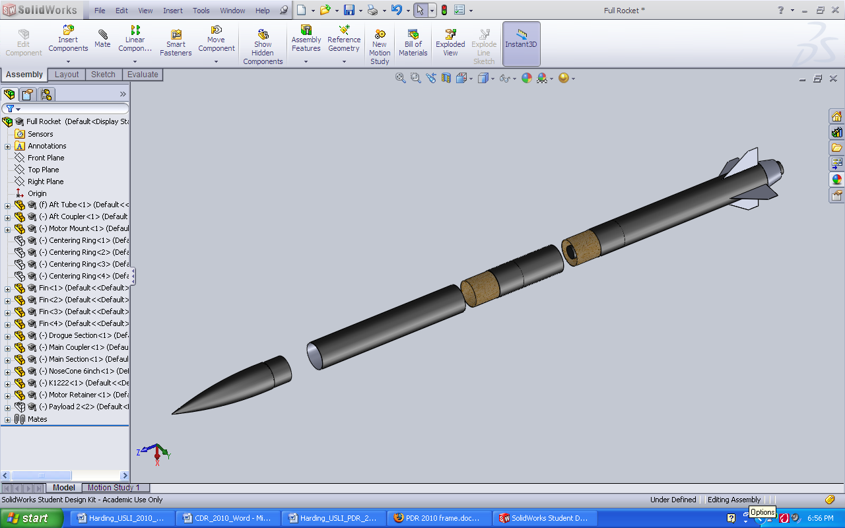
Figure 1: SolidWorks rendering of the 2011 Flying Bison rocket
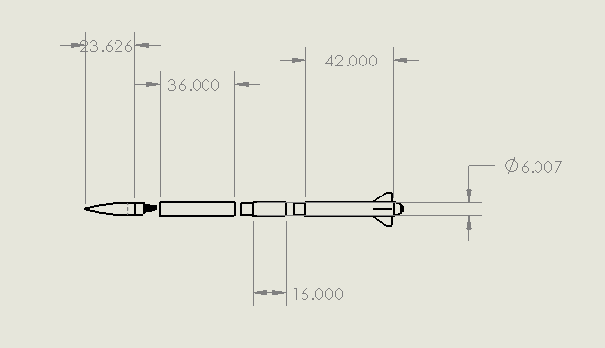
Figure 2: Dimensional drawing
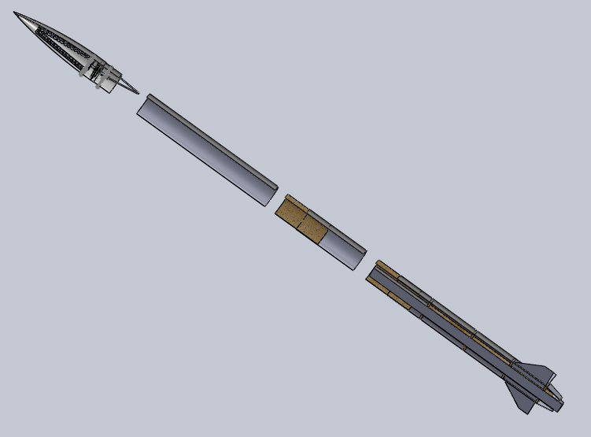
Figure 3: Cross section view of the 2011 rocket with bulk plates suppressed.

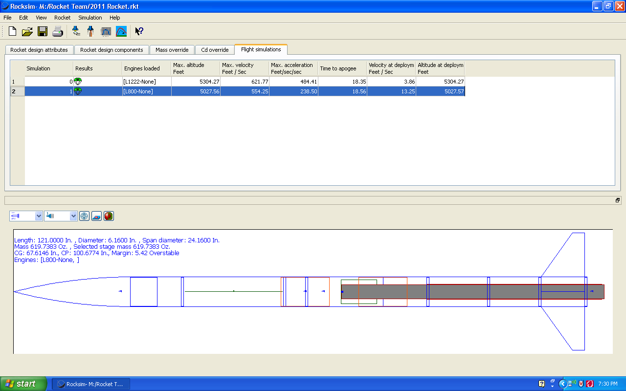 Figure 4: RockSim rendering of 2011 rocket.
3.2 Recovery subsystem

3.2.1 System analysis

To determine the proper sizing of the parachutes, Rocksim simulations have been completed to determine which parachutes will produce an appropriate descent rate. The plot for vertical velocity can be seen just below. These results confirm our choice of a 44” drogue parachute and a 120” main parachute. The parachutes will be connected to U-bolts using a D-ring and shock cord. These have all been previously tested for strength in the laboratory in years past. We will be using the exact same material. We have tested our altimeters and will run multiple separation tests upon the completion of our airframe. We will use shear pins to keep our rocket together so the testing will help us decide the exact amount of black powder we need to separate the airframe properly.
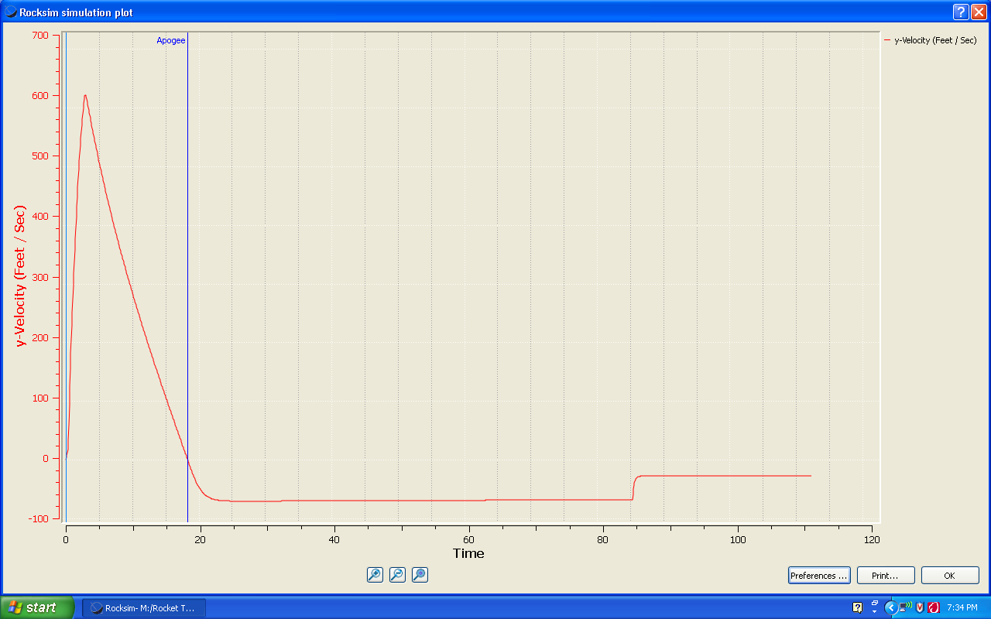
Figure 5: RockSim vertical velocity plot.
3.3 Mission performance predictions

    - Mission performance criteria
Simulation results:
Engine selection
[L1222-None]
Simulation control parameters
- Flight resolution: 800.000000 samples/second
- Descent resolution: 1.000000 samples/second
- Method: Explicit Euler
- End the simulation when the rocket reaches the ground.
Launch conditions
- Altitude: 0.00000 Ft.
- Relative humidity: 50.000 %
- Temperature: 59.000 Deg. F
- Pressure: 29.9139 In.
Wind speed model: Calm (0-2 MPH)
  - Low wind speed: 0.0000 MPH
  - High wind speed: 2.0000 MPH
Wind turbulence: Fairly constant speed (0.01)
- Frequency: 0.010000 rad/second
- Wind starts at altitude: 0.00000 Ft.
- Launch guide angle: 0.000 Deg.
- Latitude: 0.000 Degrees
Launch guide data:
- Launch guide length: 36.0000 In.
- Velocity at launch guide departure: 22.9075 ft/s
- The launch guide was cleared at : 0.331 Seconds
- User specified minimum velocity for stable flight: 43.9993 ft/s
- Minimum velocity for stable flight reached at: 68.1114 In.
Max data values:
- Maximum acceleration: Vertical (y): 484.408 Ft./s/s Horizontal (x): 0.072 Ft./s/s Magnitude: 484.408 Ft./s/s
- Maximum velocity: Vertical (y): 621.7747 ft/s, Horizontal (x): 1.9633 ft/s, Magnitude: 621.7764 ft/s
- Maximum range from launch site: 109.38195 Ft.
- Maximum altitude: 5304.62660 Ft.
Recovery system data
- P: Parachute Deployed at : 91.036 Seconds
- Velocity at deployment: 61.8352 ft/s
- Altitude at deployment: 749.99573 Ft.
- Range at deployment: 49.42180 Ft.
- P: Parachute Deployed at : 18.350 Seconds
- Velocity at deployment: 1.0347 ft/s
- Altitude at deployment: 5304.62657 Ft.
- Range at deployment: -19.69833 Ft.
Component Mass (in oz.)
Total Mass : 629.0155
- Nose Cone: 28.0000
- Payload: 112.001
- Forward Body Tube: 44.5715
  - Parachute: 28.0000
  - Avionics: 16.0000
  - Bulkhead x3: 5.5818 (16.7454 total)
- Mid Body Tube: 19.8095
  - Tube Coupler: 4.5000
  - Parachute: 4.1000
  - Paint and Glue: 40.000
  - Bulkhead: 5.5818
- Rear Body Tube: 52.0002
  - Engine Mount: 15.2000
  - Centering Ring x4: 5.9443 (23.7772 total)
  - Tube Coupler: 4.5000
  - Fins x4: 3.562025 (14.2481 total)
  - Motor Retention System: 24.0000
- Engine Assembly: 175.979
Calculated Thrust Curve
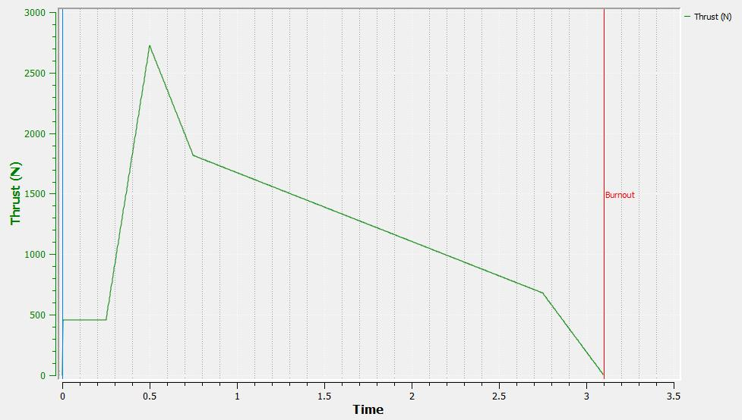
Figure 6: RockSim thrust curve

- Stability margin: 5.33 Over stable
- Center of Pressure (CP): 100.6774 in. from front
- Center of Gravity (CG): 68.186 in. from front
3.4 Payload integration

    - Integration plan

The structure of the payload is shown in Fig.7. It consists of three decks. The power supply is located on the lower deck, and the camera hangs from the upper deck. The camera is free to swing in any direction during descent. An uneven weight will hang under the camera, and the camera will face normal to the direction in which the weight is uneven. If the payload lands on an uneven surface, the heavier side of the weight will swing to the lower side of the slope. This will cause the camera to be oriented along the ground. The middle deck contains the circuitry for all of the sensors in the payload. One circuit board will be mounted on the bottom of this deck and the other two will be mounted on top.

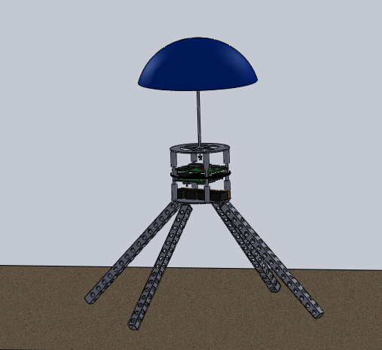
Figure 7: Overall view of the payload structure at the exact moment of touchdown (shock cords suppressed).

The four legs of the pod will be spring loaded so that they will open upon separation from the rocket. These will be tucked inside the nosecone as shown in Figure 8. One static rod will stick out of the upper platform. When the rocket lands, the parachute will fold over this rod. This will ensure that the parachute will not block the camera or other sensors while data is continually measured on the ground. A small hole will be drilled out of the side of the nosecone and main airframe to allow the sensors to take accurate data. Also, the light sensitive sensors will be directed out of this hole. At 2,500 feet of elevation, the altimeter included in the payload will set off directional charges located at the end of the nosecone. The nosecone will hang from the main rocket by a shock cord. Without the nosecone, the payload will be free to fall from the rocket. This will cause the payload parachute to deploy.

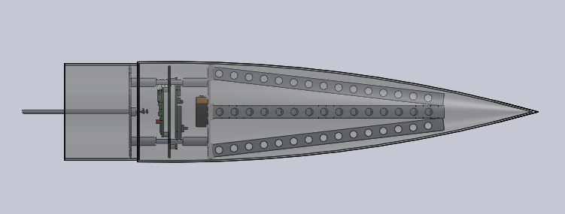
Figure 8: Placement of the payload within the nosecone.
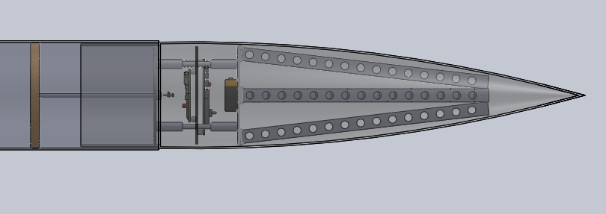 Figure 9: Placement of the payload within the nosecone (Airframe and bulkhead included).
3.5 Launch operation procedures

    - Launch system and platform

Team members will set up the launch pad at least five hundred feet away from the observation site, using a five hundred foot cord to connect the relay box to the launch control box. The stand itself uses an elevated blast plate over which the rocket is suspended. The rocket is held in place on the launch rod by two launch lugs connected to the outside of the airframe. The rail is eight feet long and may be adjusted to point in any direction. On the ground several feet from the base of the launch platform will be the nitrous oxide tank, two twelve-volt batteries to power the fill, ignition, and purge controls, and a relay box to guide each respective command. The fill, ignition, and purge commands control the regulator from the nitrous tank to the hyrid motor. The fire lines are connected from the relay box to the base of the motor.

3.5.2 Final assembly and launch procedures

The final assembly and launch procedures are those which will take place at the launch site. The motor is prepared will be initiated by placing tubing into the motor’s filling ports. Electric matches and Pyrodex pellets are attached to the fill lines to burn through and begin the ignition of the motor. O-rings (six) are greased well and slid onto both ends of the motor nitrous tube. The two chambers are connected and the fuel grain is greased and inserted into the combustion chamber. The nozzle is then installed in the motor. The motor is then inserted into the rocket and the motor retention system is put in to place. Next, both parachutes are secured and folded in their proper locations in the rocket. The payload and flight computers are secured. Charges of black powder are placed where necessary. The launch platform is set up in the configuration discussed in the previous section. When the time comes for launch, the rocket is first filled with nitrous oxide until the vent line produces a small cloud of white gas indicating that the nitrous tank is full. At this time, a countdown commences. Filling is arrested at three seconds and the launch command is armed. Ignition begins upon the completion of the countdown.
3.6 safety and environment (Vehicle)

3.6.1 Team safety officer

Edmond Wilson, Team Official, is the Safety Officer for the Harding Flying Bison 2011 USLI Rocket Team. He holds a NAR Level 2 Certification.

    - Preliminary failure modes and mitigations

      - Airframe:

- Airframe fails to hold motor in place causing motor to tear through the airframe.
- We will reinforce the hardware which holds the motor casing thrust ring in place.
- Motor falls backwards out of motor housing tube during flight. We will use a commercial motor retainer to prevent this failure.
- The airframe fails to separate when separation charges ignite. We will sand down the junctions properly to ensure that they are loose enough to separate but still tight enough to hold together during flight.
- Fins become separated or tear through the airframe upon hard landing. We will reinforce attachment of the fins to the airframe and to the motor housing tube with Kevlar or nylon using epoxy adhesive.
- Shock cords separate when deployed. We will perform tensile strength measurements on the shock cords to pick the minimum size cord that will be strong enough and increase the size to twice tensile strength specified.
- The primary flight computer malfunctions. We have a second flight computer that will provide the same functions and sensors to the rocket as the primary, which we can use in the case of any damage or malfunction to the primary computer.

      - Payload:

- Batteries will fail during launch. We will install brand new fresh batteries as part of the rocket preparation. Each electronic system will have its own battery supply. We also will bring extra charged batteries to the launch site.
- Circuit boards and batteries break off their mounting boards and devices at launch. We will pay special attention to making these mounting boards and battery holders as strong and solid as possible.
- Cables detach during pre-launch or launch. We will reinforce the connections with tape to prevent separation.
- Launch Operations:
- Five hundred foot cable connecting rocket ignition box at the rocket launch pad with the operator controls fails. We can test the connectivity prior to launch and correct any problems.
- Battery failure in operator control box. We will bring a back-up battery and make sure the original battery is charged and tested just before launch.
- Nitrous oxide cylinder too warm or two cold producing pressures below 600 psi or greater than 900 psi. We will keep the nitrous in a thermal container that can be filled with either ice water or hot water to adjust the temperature. In April one usually needs to cool the nitrous cylinder.

    - Personnel hazard research

- Exposure of skin and eyes to epoxy resins – Exposure of hands to epoxy adhesive materials will be minimized by the use of protective eyewear and gloves.
- Exposure of skin and eyes to fiberglass fibers and Kevlar™ fibers – Exposure of hands to fiberglass fibers and Kevlar™ fibers will be minimized by the use of protective eyewear and gloves.
- Exposure of eyes and lungs to acrylic spray paint – All painting will be done with doors to shop opened and vent fan on. Protective eyewear and a mask covering nostrils and mouth will be worn.
- Trauma to body from improper use of hand tools – Proper use of hand tools will be explained as needed for each process undertaken.
- Trauma to body from improper use of metalworking machines – All will wear protective eyewear, and instruction on preventing injury to the body during work periods will be conducted repeatedly for each phase of the work.
- Proper use of the nitrous oxide cylinders, regulators, and controls will be explained before use. The Safety Officer will supervise launch activities dealing with nitrous. Pressures between 600 and 900 psi will be maintained on the nitrous storage cylinders by surrounding them in thermal jackets in which ice water or warm water can be added as needed. Personnel will be at least 500 feet from the launch area while loading the nitrous into the rocket motor. This will prevent anyone from receiving frostbite from an uncontrolled leak. All operations for the nitrous will be done by electrical valves except for initial turn-on of the main cylinder valve during initial launch setup and after launch. A dump valve is part of the equipment in case of failure to launch. Once a rocket is launched or aborted, the main cylinder valve will have to be manually turned off.

3.6.4 Environmental Concerns

- Our procedure, if followed correctly, should pose little or no harm whatsoever to the environment.
- The blast plate will protect surrounding vegetation from the blast of ignition.
- Following every launch, the site will be cleaned up of any trash or debris from launch or recovery area.
- Only two or three people will be sent to recover the rocket, and they will be respectful of the surrounding environment.
- The oxidizing agent, nitrous oxide, will leak into the atmosphere in very small amounts, where it will quickly disperse. The amount is much too small to cause any amount of harm to the environment.
- The fuel, hydroxyterminated polybutadiene, is essentially only rubber. The spent fuel grain will be disposed of in a landfill, where it will eventually degrade into water and carbon dioxide.
4. Payload Criteria
4.1 Selection, Design, and Verification of Payload Experiment

    - System design review

The payload consists of 3 circuit boards; one with the AVR Micro-controller, the pressure, temperature, relative humidity, UV/radiation sensors, x and y accelerometers, and one board with the z accelerometer. The last board consists of the camera and its batteries. Moreover, a G-switch will also be in the same area, to turn the system on, and two 9 V batteries.

4.1.2 Payload subsystems

- Temperature Subsystem -- the temperature transducer will be measured with a National Semiconductor LM50CIM3 transducer. This temperature transducer reads directly in Celsius degrees (10 mV/⁰C). The nonlinearity is less than 0.8 ⁰C over its temperature range of -40 ⁰C to +125 ⁰C. The accuracy at 25 ⁰C is ±2% of reading. It operates with any single polarity power supply delivering between 4.5 and 10 V. Its current drain is less than 130 mA.

- Pressure Subsystem -- the pressure transducer is an ASDX015A24R Honeywell device with a pressure measuring range of 0 to 15 psi and a burst pressure of 30 psi. It is powered by voltages in the range of 4.75 Vdc to 5.25 Vdc and has a current consumption of 6 mA. It will operate in the temperature range of -20 ⁰C to 105 ⁰C. It survives 10 gram vibrations from 20 Hz to 2000 Hz and can survive a 100 g shock for 11 ms. Its lifetime is 1 million cycles minimum. The device is accurate to ±2% H full scale.

- Solar Irradiance and UV Radiation Subsystem—an Osi-optoelectronics UDT-455 UV/LN component which is a photodiode-amplifier hybrid. While operating the temperature range is 0 - +70°C. A spectral range can produce a response of 200nm to 1000nm. Supplied voltage usually is of ±15 V, hence the quiescent current supplied will be of 0.9 mA.

- Relative Humidity Subsystem— a Honeywell HIH 4000-Series component will be used. With current operating at 200 microA and calibrated at 5Vdc, ±2% RH(Relative Humidity), 0-100% RH non-condensing, 25 °C is possible. The sensor is a laser trimmed thermo set polymer capacitive sensing element with on-chip integrated signal conditioning. The sensing element's multilayer construction provides excellent resistance to application hazards such as wetting, dust, dirt, oils, and common environmental chemicals.

- Camera Subsystem -- a Vivitar Vivicam V7022 Graphite with 7.1 MP resolution and 4x digital zoom will be used. The flight computers will initialize the data capture at apogee and a pull switch will initialize the camera during descent. A 555 timer with a one-shot trigger will take the pictures after the payload has touched the ground.

- There is one 1-axis low-range accelerometer, ADXL103CE, and one 2-axis low range accelerometer, ADXL203CE from Analog Devices. There is one 1-axis high-range accelerometer, AD22279-A-R2, and one 2-axis high range accelerometer, AD22284-A-R2. All of these devices have an output full-scale range of 37 g. All have a non-linearity of approximately 0.2% of full scale. They require a power supply capable of producing 4.75 Vdc to 5.25 Vdc and at least 3.0 mA. The operational temperature range is -40 ⁰C to +105 ⁰C. Their maximum rating is 4000 g acceleration for any axis.

    - System performance characteristics

·Performance characteristics are listed in the subsystem description preceding this entry. To verify that each subsystem works, we will use the multi-meter to read definite voltages and to expect assured voltage drops or increases respectively.

    - Verification plan
After testing each part of the payload individually and proving that it works, it will be tested as a whole system with the full scale model launch.

4.1.5 Preliminary integration plan

See Section 3.4

4.1.6 Instrument precision, measurement repeatability, and recovery system

For instrument precision see individual instrument. Each instrument can be used more than one time and once the memory is recovered from the microprocessor the payload will be ready to fly. The recovery system will all so be multi use but it will need a new separation charges to deploy the parachutes.

4.2 Payload Concept Features and Definition
4.2.1 Creativity and Originality
Due to our choice of selecting the SMD suggested payload, our payload is not particularly creative in its objectives. We feel our creativity is seen in the design of our actual payload pod. We chose to build a system that would release spring loaded legs after separation from the payload. We are implementing springs on the circuit board decks to help the system handle the forces during landing. We are also including a trigger on a foot of the payload to alert the system when it has landed. We had to solve the problem of how to have a camera oriented to take a picture of the horizon. We decided the best option for this was to hang the camera from a top deck in a manner that it will always hang in the correct orientation.
    - Uniqueness or significance
Although finding data such as temperature in our atmosphere is not overly significant, finding the temperatures of the atmosphere for distant planets could prove to be very useful. This payload construction leads our design team to understand and build a system that could possibly be used in another atmosphere.

    - Suitable level of challenge
This is a very appropriate project for college science and engineering students, CAD design, metal and electronic fabrication, tensile strength machines, presses and wind tunnels will be used. There will be lots of testing done and calibration. Finally, reports such as this one plus posters and oral presentations will all help to enhance the education of participants with real-world, hands-on activities.
4.3 Science value

4.3.1 Payload objective
The payload must complete the following objectives:
o Test and calibrate a pressure sensor that will record pressure at constant intervals over the rocket trajectory
o Test and calibrate a temperature sensor to be used to record temperature as a function of altitude
o Test and calibrate a low sensitivity and a high sensitivity 3-axis accelerometer that will record the acceleration throughout the flight trajectory.
o Test and calibrate the relative humidity sensor to accurately measure the humidity in the air during the flight.
o Test and calibrate the UV radiation sensor to detect ultraviolet radiation from 200 to 1100 nm. The spectral response of the silicon photodiode detector is a good match to the spectrum of solar irradiance.
o The camera must take two pictures during descent and three after landing.
4.3.2 Payload success criteria
Success will be accomplished when
  - the sensors excel by gathering the proper data and store it in the computer memory. That is, measurements taken at least every five seconds during descent and every 60 seconds after landing ending within 10 minutes after landing.
  - and, the pictures taken during descent and after landing are properly oriented.

4.3.3 Experimental logic, approach, and methods

We will conduct our atmospheric research by using simple sensors integrated onto a payload pod. We will build a circuit to take data at a certain rate and combine that data with the data from our altimeters to study the changes of the dependant variable with the change in altitude.

4.3.4 Variables and controls

Variable will be the height at which the measurements are taking place. The measurements will be ambient pressure, humidity, temperature, and sunlight intensity. All of the sensors’ operating ranges of values we are expecting.

4.3.5 Relevance and error analysis

The data that will be collected will help show how the sun’s energy heats the air. Data collected will be compared to that anticipated when possible. Accuracy can then be estimated. Error analysis will be made during laboratory testing once the payload is complete and testing begun

4.3.6 Preliminary experiment process procedures

The payload section remains inactive until the rocket reaches apogee and the drogue parachute is released. At this time, the payload receives a signal to begin to take data. When the rocket has descended to 2500 feet, the nose cone is separated from the rocket and the payload is released which causes the spring loaded legs to be pushed to their final position. As the payload is separated, a timer is begun to send a signal to the camera to take pictures during the second half of descent. Upon landing, a trigger will be activated for the camera to take three more pictures and for data to be recorded at a new rate. The payload is located using the GPS system and data is retrieved through a USB port.
4.4 Safety and environment (payload)

4.4.1 Safety officer

Edmond Wilson, Team Official, is the Safety Officer for the Harding Flying Bison 2011 USLI Rocket Team. He holds a NAR Level 2 Certification.

    - Risk analysis
One significant concern for the payload integration is that the charge which blows away the nosecone will damage the payload circuitry. This is another reason for the implementation of the static rod. When the charge is set off, the payload will brace against the rod rather than being knocked back violently by the blast. It will also be optimal to use the smallest charge possible. If this failure possibility is discovered to be probable, adjustments to design will be made. Placement of the payload at the front of the rocket will cause the rocket to be top heavy. This may need to be addressed by weighing down the bottom of the rocket.
Also see section 3.1.6

    - Personnel hazards
Personnel hazards include:
Injury to eyes or hands while machining payload parts. All will wear protective eyewear and instruction on preventing injury to the body during work periods will be conducted repeatedly for each phase of the work.
Proper use of hand tools will be explained as needed for each process undertaken.
Instruction on how to solder properly will be given when electrical circuits are being assembled.
No dangerous chemicals will be used in the construction and operation of the payload.
Also see section 3.6.3

4.4.4

There are no significant environmental concerns for the construction or operation of the
payload.
5. Activity Plan
Activities:
Launch Day: 10-30-10 (Completed) We held a launch day for new members and anyone else who was interested in coming to see the team fly our 2010 competition rocket and a smaller scale rocket.
Cub Scouts: 11-29-10 (Not completed) We will meet with a Cub Scout troop here in Searcy to give an interactive presentation on our rocket project. We are going to let the children see some of the rockets from previous competitions and teach them some basics of rocketry.
Spring 2011 (Not completed) We will follow up on our contact with the Cub Scout troop by helping the children build their own model rockets and fire them.
Westside Elementary: Ongoing (Not completed) We have sent a representative to teach a lesson on rocketry and we will have another visit with the school to launch rockets that the students have built.

Elementary School in Little Rock: Spring 2011 (Not Completed) We have made a contact with an elementary school teacher in Little Rock in the past week who is interested in having our team help with educational rocketry lessons. We are following up currently and finding out more about this opportunity.

Budget:

We have currently allocated $100 dollars for educational outreach. We settled on this number because we have found in the past that out outreach opportunities have required very few expenses.

Other educational engagement opportunities:
We have planned to work with the Roosevelt Institution on campus to teach nearby students at rural schools about science. We are still in the planning stages of this project and plan to begin execution in the spring.

6. Conclusion

· The preliminary plan for the design of the hybrid rocket, launch stand, and
payload has been proposed and agreed upon by team members.
· Dimensional drawings have been made, but more work needs to be done in this area.
· The launch stand has been built and ready to use.
· We will decide on a finalized payload weight and finalize our fin selection to complete
our parts list to begin work on the airframe.
· The payload electronics and embedded controller, along with the avionics need
to be finalized so these parts can be ordered with a goal of beginning construction shortly after the return from winter break.
· Detailed documents need to be prepared for:
Pre-launch
Launch
Payload
Payload deployment
Safety Procedures
Testing needs to be done on airframe components
Calibration and testing of all payload components and avionics needs to be done

The team feels confident that we will be able to produce an excellent rocket upon our arrival at the final competition. We have a strong handle on our airframe, and plan to begin constructing as soon as parts are available. This year we have already conducted a test flight with a previous competition’s rocket. This has given our avionics division and our launch operations group a lot of experience. We encountered problems at that launch that pushed the team to use problem solving skills and work together. It also led to a very detailed understanding of our launch system and procedures. We continue to plan for outreach and hope to soon be very active in the community. Our payload is the area that we will need to focus on the most before the next report is turned in. We will work hard to finalize our design.

